Jame's Horde Leveling Guide - Chapter IV (51-60)
Jame's Horde Leveling Guide - Chapter IV (51-60)
Changelog
This is v2.0 of the guide. It has been revamped as mentioned in this news post to adapt to patch v2.3 changes. You can still find the old version of the guide here. At the same time, many other improvements have been made:
- Introduction/Addons section has been updated
- Kill everything on your way rule has been lifted unless you lack experience compared to the progress described in the guide
- Grinding sessions removed and instances aren't part of the leveling process anymore (no dependancy on groups)
- Quests that aren't elite anymore have been integrated
- Maps have been remade and a lot of errors have been corrected
- Leveling should be possible at a faster pace than before
- The guide takes you beyond level 60 now, if you wish to finish old world content to have more Outlands quest left for gold making later on
Courtesy to Wowhead for some of the images!
Introduction
This guide starts at level 51. However I hope that you followed the previous chapters of my guide. Because a lot of pre-questing and flight path gathering is done in it and we will need it for this chapter. If you didn't, it's not that bad, you'll just have some more grinding to do to catch up. If you need guides for any other level range (from 1-51 for example) please take a look at this page.
This guide is optimized for FAST leveling with a minimum of grinding sessions. Quests are important, they give rewards and faction and are less boring than pure grinding.
Some people say that grinding is always faster than questing, this is true in theory when you don't know which quests to take and which to avoid, and what is the best order to do them in. With this guide, questing will be very efficient and much better than pure grinding. Follow each instruction carefully and you will see for yourself.
The quest choices and order to do them in are optimized so that you run as few as possible while doing the most possible and then turning several quests in at the same time. This guide will be very useful for both veteran and novice players. I try to keep the amount of information as short as possible. So even the guide itself is optimized for the minimum reading possible, to save time! Let's get started immediately then! Everything described in this guide can be done solo (besides when I say otherwise). However you can follow this guide while duoing, grouping, it's not a problem, it works too.

Basic rules
- As soon as you see that you start to lack experience compared to the progress described in the guide start to kill everything that is on your way while traveling and that gives experience (Yellow mobs preferably, but greens are ok if they are just 3-4 levels below you, not more).
- Spend your talent points so you do the most damage possible. (e.g: Priest should specialize in Shadow Talents, Warriors in Arms/Fury, Rogues Combat/Assassination, etc).
- Don't waste your time trying to find groups for questing, you can solo everything that is described in this guide.
Only group with someone when it's not gonna be a waste of time (e.g: meeting the person at the other end of the zone to show him the way to where your quest is - that is a waste of time)
- Try to always log out in an inn or in one of the major cities when you take a break.
- If I don't mention a quest, it means I consider it a waste of time, so don't take it thinking I forgot a quest here and there, I didn't. Also don't abandon a quest unless I say you should.
- Sometimes I will be making lists of quest you should have before starting with an area, that doesn't mean I will list the whole quest log, JUST the quests that interest us for the moment.
- When I say you should bind (make an inn your home location) somewhere, it's for a good reason, and it will save you much time. Don't change your home location until I say so.

Useful Addons
Something that's amazingly useful is the Ace2 updater. Download and install it and the program will present you with a list of addons which all use the same library (hence they consume very few ressources). From that list you can choose addons that interest you (I downloaded Fubar quest mod, Fubar location, Cartographer, Bartender and a mod to make my UI look better) and the program will install all the addons for you. Furthermore you can run the program every time before you launch WoW and choose to update all installed modules for you.
Side Note:
If your addons are not being loaded when you enter the game you might need to log out to your character selection screen and click on "Addons" in the left lower corner. Tick the box that says "Load out of date Addons". Relaunch WoW.

Shopping List:
- Level 51: 15x Silk Cloth (you only need this if you decide to do the optional circuit in Searing Gorge)
- Level 55: Mithril Casing - Made by Engineers. Components are 3x Mithril Bars
- Level 60: 2x Thorium Bars
These might not always be up for sale, so start checking early.
These might not always be up for sale, so start checking early.

Color Code:
- Quests
- Items
- Locations
- Quest objectives to kill
- NPCs
- Locs
Level 51

Fly to Camp Mojache.
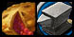Sell, repair and restock food and drink (4 stacks).
Set your hearthstone to Camp Mojache.
Turn in [47]Testing the Vessel and get the follow up [47]Hyppogryph Muisek.
Also get:
- [50]Dark Heart
- [50]Vengeance on the Northspring
- [52]The Strength of Corruption
from Talo Thornhoof, who is in a house close to the eastern exit of Camp Mojache.
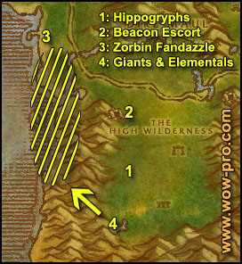
1. Ride west, stay on the road till after the first stone bridge, then go southwest, past the yeti cave and you should soon encounter some hippogryphs (56,62). Kill 10 of them and use the Hippogryph Muisek Vessel on their corpses after having looted them. Check the status of the quest [50]Natural Materials, and if needed, stay in this area and kill hippogryphs until you have 20 Resilient Sinews and 33/40 Metallic Fragments (we'll get the 7 last one off giants soon).
2. Once you have harvested 10 Hippogryph Muiseks, go to the yeti cave and do the Distress Beacon escort if you haven't done it already. Read the tips I gave in the previous guide (level 46) before you start the quest. If you still don't have the Feralas distress beacon, don't worry, we still have quite a lot to do in Feralas so it will most likely drop before we leave the zone. Proceed with the next paragraph.
3. Get back on the road and ride westwards till you reach the shore. Next to the pier you should find a goblin named Zorbin Fandazlle (45,44). Get his 2 quests: [48]Fuel for the Zapping and [48]Zapped Giants.
4. Go south along the shore and start killing water elementals. Look for giants as well, they are elite but if you use the Zorbin's Zapper on them they become totally manageable. Keep killing elementals and giants until you got 15 Miniaturization Residue and 10 Water Elemental Core.
Once finished, go turn in your quest at Zorbin Fandazzle. Don't get the follow ups.
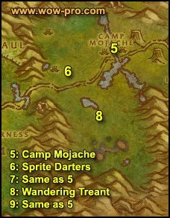
5. Hearthstone to Camp Mojache.
Turn in [47]Hippogryph Muisek, get the follow up [45]Faerie Dragon Muisek.
6. Ride west to the Sprite Darters area (70,47), kill them and use the Faerie Dragon Muisek Vessel on their corpses after having looted them. Do that 8 times.
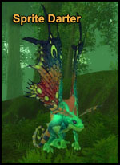
7. Ride back to Camp Mojache. Turn in [45]Faerie Dragon Muisek, get the follow up [50]Treant Muisek.
8. Ride southwest to the alpha gnoll camps (71,57). Kill the gnolls in the area while waiting for a Wandering Forest Walker to pass by. They are level 45ish and non-agressive treants. One should pass by every 5 min, so just grind on gnolls while waiting. Kill 3 of those treants and use the Treant Muisek Vessel on their corpses after having looted them.
9. Ride back to Camp Mojache, turn in [50]Treant Muisek and get the follow up [50]Mountain Giant Muisek (elite).
Sell, repair and restock food/drink (4 stacks).
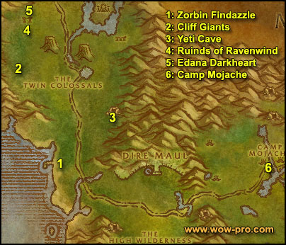
1. Ride west, follow the road, make a stop by the yeti cave if you got the distress beacon recently and escort the robot chicken. If you can't - or already have done - the chicken escort, follow the road west until you reach the shore at the total opposite side of the map, where Zorbin Fandazzle is (45,44). Get his quest [55]Again with the Zapped Giants.
2. Get back on the road and ride north.Follow the road until you are exactly where "The Twin Colossals" is written on the world map. Go directly west and soon you should find Gregan Brewspewer, who is a dwarf standing next to a small white tent (45,25).
From Gregan's camp, go northwest until you encounter some Cliff Giants/Land Walkers (40,22). Use your Zorbin's Ultra-Shrinker on them, kill them and loot them, then use the Giant Muisek Vessel on their corpses.
Stay in this area and do this 7 times. You can destroy the miniature residue, the Zapper and abandon the quest [55]Again with the Zapped Giants, it's just 500 exp and the long ride isn't worth it. We just took the quest because we needed the Zapper.

Note: Also kill the treants passing by if you still lack Splintered Logs for the quest [50]Natural Materials.
3. Ride southeast to the yeti cave (51,32). Kill Rage Scar Yetis until you get 10 Rage Scar Yeti Hide and a Perfect Yeti Hide (rare drop). When you get the Perfect Hide, right click it and get the quest [48]Perfect Yeti Hide.
4. Get back on the road and go north, past the twin colossals, then turn west to the Ruins of Ravenwind (41,12). Time to kill some harpies, kill everything in the ruins until you have completed [50]Vengeance on the Northspring and have found a Horn of Hate, which can drop from any harpy.
5. Once you have done that, go to the northernmost part of the ruins, you should find two identical stones at (40,8 ).
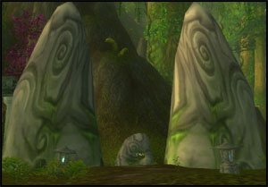
We're about to summon a level 50 harpy. When you are ready, go in between the two stones at (40,8 ) and blow the Horn of Hate. Wait about 20 seconds and she should appear in between the two stones.
Once she's dead, loot Edana's Dark Heart off her. If you got the distress beacon and still haven't done the chicken escort quest, go do it now.
6. Hearthstone or ride back to Camp Mojache.
In Camp Mojache, turn in the following quests:
- [50]Mountain Giant Muisek
- [50]Natural Materials, take the follow up [50]Weapons of Spirit, wait 20 seconds for witch doctor Uzer'i to do his script then turn in [50]Weapons of Spirit.
- [48]Improved Quality
- [48]Perfect Yeti Hide
- [50]Vengeance on the Northspring
- [50]Dark Heart
Fly to Orgrimmar.
Set your hearthstone here.
In Orgrimmar go to the Valley of Spirits and find Uthel'nay (check your minimap for a yellow question mark), turn in [47]The Gordunni Orb.
Optional: While you are at Uthel'nay, take the quest [42]Shadowshard fragments, if you intend to go to Maraudon in the future.
Ride to the drag, go up the stairs to the left immediately after entering it, keep going until you see a yellow question mark showing where Zilzibin Drumlore is. Turn in the quest [48]Rise of the Silithid. Get the other quest [53]March of the Silithid.
Go to Dran Droffers just northeast of Zilzibin, also in The Drag, turn in [48]Ripple Delivery.
Finally ride to the Valley of Honor and find Belgrom Rockmaul, in front of the Warrior's Guild. Turn in [45]A Grim Discovery. Get his other quest: [53]Betrayed.
This should make you ding 52 or you should be close.
Level 52

Sell, repair, visit your class trainer, restock consumables (4 stacks of food/drink).
If you are planning to go to Searing Gorge (optional circuit, read more about that in a bit) buy 15 silk cloth if you don't have that on you already.
When you're ready to go again, fly to Ratchet. Take the boat to Booty Bay.
In Booty Bay turn in the [45]Deliver to MacKinley at "Sea Wolf" MacKinley (close to the inn) and all the Rescue OOX-22 quests you completed at Oglethorpe Obnoticus (2nd house to the right of the forge), if you completed any, that is.
If you completed all 3 rescues you get and extra quest [50]An OOX of your own. You'll get another of those useless pets and 10 200 exp as well! Which is why going through the pain of doing those 3 escort quests is in the end worth it.
You should have the following quests:
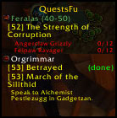
Note: Even if you don’t want to do the optional circuit, still get the Thorium Point flight pass, it will save you time in the future.
== OPTIONAL CIRCUIT ==
This circuit includes all the quests of Thorium Point and Searing Gorge, which I decided to make optional for the following reasons :
- Searing Gorge and Thorium Point quest objectives appear to be heavily camped since patch v2.3. I’m not sure if this is a temporary phenomenon, but the entire circuit wasn’t doable for me because of too many people trying to do the same quests at the same time (for 3 consecutive days). So if this is the case on your server as well, don’t worry, just skip this circuit.
- Experience wise, if you are at level 52 when you start this guide you don’t need the circuit (it’s already starting to get low level). However you might still want to do it for certain quest rewards and faction, the choice is up to you. If you do it however, you’ll have to skip quests elsewhere.
- An optional circuit can be a great thing for people who are only level 50/51 and who didn’t follow Jame’s Horde Leveling guide before. This way you have a platform to jump into the guide and to catch up experience wise without grinding.
The circuit :
In short (if you already know the way): Go to Searing Gorge.
In detail: Fly to Kargath, then go south/southwest and you will find the entrance to the Searing Gorge on the western end of the Badlands at (3,61).

Inside Searing Gorge:
Follow the trail north and then west around the area named "The Cauldron" and find Kalaran Windblade (38,39). Get the quest [48] Divine Retribution then talk to Kalaran again and go through his dialogue. Turn in the quest and get the follow up [48] The Flawless Flame.
Go a bit further west and you should find a path going up the mountain to Thorium Point (32,33).
In Thorium Point, get the flight path.
Then find a "wanted poster" at (37,26). Right click it and get the quests:
- [48] JOB OPPORTUNITY: Culling the Competition
- [48] STOLEN: Smithing Tuyere and Lookout's Spyglass
- [50] WANTED: Overseer Maltorius (Elite)
Get the 3 quests from Hansel Heavyhands:
- [49] Incendosaurs? Whateverosaur is More like It.
- [49] Curse These Fat Fingers
- [49] Fiery Menace! and [50] What the Flux? from Master Smith Burninate.
Note: If you ever need to sell and repair, you should go to this NPC.
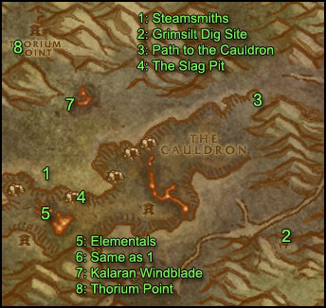
1. First, go south where you'll find a big wheel (its part of a dark iron dwarven forge) and kill all the Dark Iron Steamsmith you find there (39,50), there should be 5 or 6 around here.
Hopefully one of them will drop the smithing tuyere you need. If not, lets just go on, we'll come back here later.
2. Start heading east and kill any elemental or Heavy War Golem you find on the way. Also kill Dark Iron Taskmasters and Dark Iron Slavers on your way. Don't wait for respawns, just kill them while going east. At (59,35) mount up and ride southeast to Grimesilt Dig site and find a little wooden house at (65,62) behind the dig site, which actually looks like some public toilet. Right click it and get the quest [45] Caught!.
Start killing the Dark Iron dwarves in the camp as well as the golems around here. After you have killed 8 Dark Iron Gelologists and got 15 silk cloth (if you don't have them, kill more of those dwarves, they drop silk cloth), go back to the Wooden Outhouse and turn in the quest, don't get the follow up though.
3. Ride north to the entrance of The Cauldron (63,38). Inside the Cauldron, kill all the Dark Iron dwarves and Elementals you find. The Blazing Elementals and the Magma Elementals drop the Hearts of Flame you need. Also kill any Heavy War Golem you find.
Note: If while killing dwarves you find a "Grimsite Outhouse Key", right click it to start the quest [47] The Key to Freedom, we will turn it in later on.
4. Progress westwards inside the Cauldron until you find an iron slope going up at (46,53). Follow this slope until you find an entrance to the Slag Pit at (41,54).
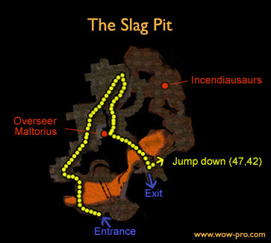
Inside the Slag Pit go across the bridge, on your left will be the Quarry Gate, go through it.
Work your way northwards until a bigger room where you'll find Enslaved Archeologists and a big 52 Elite elite golem lying down (ignore it). Go up the iron slope, midway on the slope you have 2 options, straight or left. Go straight. You'll soon enter a room with several pairs of taskmasters and slavers.
In this room further in and to the right you'll find Overseer Maltorius and 1 Dark Iron Sentry. Kill them and loot the Head of Overseer Maltorius.
Behind them you can find Secret Plans: Fiery Flux. Loot them.
From the same big room, go over the iron bridge which is on the opposite side of Overseer Maltorius. On the other side of the bridge, jump down to the lower floor at the drop off spot indicated on the map. From this spot go east and you should find Incendosaurs, kill 20 of them.
5. When done with that, go back up the ramp and then get out of the Slag Pit, jump down back into the Cauldron and work your way westwards looking for Blazing Elementals until you get 4 Heart of Flame.
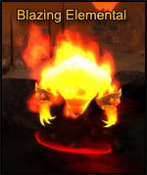
6. Then go to the iron slope you took previously at (46,53) Follow this slope but this time skip the first entrance to the Slag Pit, and get on the elevator (40,54). The elevator will stop at the 1st floor and 2nd floor but don't get off. Wait until it's on the 3rd floor from there you can get out of the Cauldron.
Kill every Steamsmith you find around the buildings infront and to the left of you after getting off the elevator (39,50). There is 5 Steamsmiths at this spot, pray that one of them drops a smithing Tuyere. If not don't worry, we'll kill more of these later.
7. Kill every Heavy War Golem around and go north to Karalan Windblade (39,38). Turn in the quest and get the follow up [48] Forging the Shaft
8. Go to Thorium Point and turn in the quests you have completed. When turning in [50] What the Flux?, Master Smith Burninate will open 3 new quests to you, but they are just to work on Thorium Brotherhood faction, so don't bother unless you care about this faction.
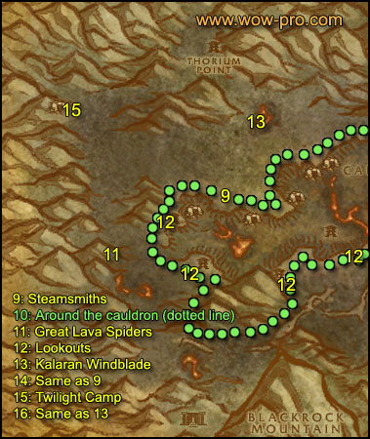
9. Sell and repair, then go south to the big dwarven forge/wheel (39,50) and kill Dark Iron Steamsmiths again.
10. Then go west and then south, basically staying close to the cauldron but never going down in it. Kill every dwarf and golem on your way. Basically make circles around the cauldron.
11. Also make sure you kill any Greater Lava Spider on sight.
There is alot of them in an area west of the Cauldron (28,47).
12. While doing circles around the Cauldron, make sure you kill the Dark Iron Lookouts you can find at the feet of each of the 4 watch towers. They drop the spyglass you need for one of the quests.
13. Anyway, as soon as you got 8 Thorium Plated Daggers, go back to Kalaran Windblade, even if you didn't finish the other quests yet.
Note: The Thorium Plated Daggers can drop on any Dark Iron Dwarf, it generally takes me a full turn around the Cauldron to get 8 of them.
Turn in the quest at Kalaran Windblade and get the follow up [50] The Flame's Casing
14. Go kill the 5 Dark Iron Steamsmiths again before you go, if you haven't got the Smithing Tuyere yet.
15. Go west to the Twilight Camp at (24,34). Now all that is left for you to do is kill Twilight mobs (any of them) until you get aSymbol of Ragnaros
16. When you got this item, you can go back to Kalaran Windblade. You can also go to Thorium Point for a quick sell/repair if necessary.
Turn in your quest at Kalaran Windblade and get the follow up [50] The Torch of Retribution.
Turn it in, watch him craft the torch, then get the quest [50] The Torch of Retribution.
Right click the stick surrounded by a green aura, complete the quest. Talk to Kalaran again, get the quest [50] Squire Maltrake.
Turn in the quest at Squire Maltrake and get the follow up [52] Set Them Ablaze!
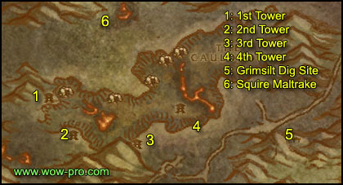
1. Go southwest to the first watch tower (33,52). Don't forget to kill any mob you might still need on the way (golem, spider, dark iron steamsmith or lookout)
When you are at the 1st watch tower, clear any mobs guarding it, then search the Torch of Retribution in your inventory, equip it, and put it on a hotkey.
Search for a small bowl on the floor named "Sentry Brazier" and right-click it.
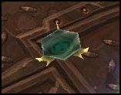
It will be instantly lit.
2. Do exactly the same thing on the 2nd tower (35,59).
3. Then the 3rd tower (43,63)
4. And the 4th tower, which is accessible only through a bridge at (52,57).
Note: The 4th tower is the one with the most Dark Iron Lookouts, in case you didn't get a Lookout's Spyglass.
5. After you are done setting the 4th tower ablaze, go east to the Grimsite Dig Camp and go turn in [47] The Key to Freedom at the wooden outhouse.
6. Go back to Squire Maltrake (38,39), turn in the quest and watch Kalaran transform into a dragon, make his speech and then he'll fly away. Right click the treasure chest named "Hoard of the Black Dragonflight" next to where he was, accept the quest [50] Trinkets...
Then click the chest again and complete the quest. Look in your inventory for the red box named Hoard of the Black Dragonflight, open it and loot what's inside of it (especially the Molt, which you will need later on for a quest)
You don't need the Torch of Retribution anymore, you can destroy it or bank it.
Now there's only one thing left for you to do: finish all the quests that you haven't finished yet, and you already should know where all the mobs you need are. Once you have completed all these quests, go back to Thorium Point and turn them in.
== END OF OPTIONAL CIRCUIT ==
Hearthstone/travel back to Orgrimmar, right after hearthstoning, get the quest [50]Assisting Arch Druid Runetotem from the innkeeper.
Go to "The Drag" and find Jes'rimon, he's at the top floor of the alchemy building (55,34). Get his quest [52]Bone-Bladed Weapons.
Sell, repair, restock consumables (if needed).
Fly to Thunder Bluff.
In Thunder Bluff, go to the Elder Rise and talk to Hamuul Runetotem, get the follow up [50]Un'goro Soil.
Fly to Gadgetzan.
In Gadgetzan turn in [53]March of the Silithid and get the follow up [53]Bungle in the Jungle. Also get [54] Super Sticky from Tran'rek.
Ride southwest to the slope going down to Ungoro Crater (27,57).
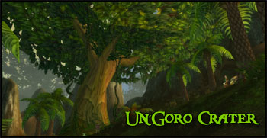
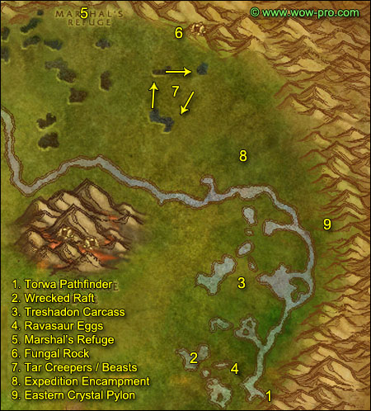
1. Go down the slope and find Torwa Pathfinder to the right up a small hill (71,75). Get the 2 quests:
- [53] The Fare of Lar'korwi
- [55] The Apes of Un'Goro
**From now on, while in Ungoro Crater look around for crystals. There is 4 types of crystals:
Red, Blue, Yellow and Green crystals. Loot them anytime you see them until you got 7 of each color. Also look for Ungoro Dirt Piles and loot the Un'goro soil from them. Un'goro soil also drops fairly often from most creatures in Un'goro crater, you should try to have at least about 50 Ungoro Soil before we leave Un'goro, because we will need extra soils for 2 other quests which will require you to transmuate Un'goro soils into Morrowgrain.**
**Kill every dinosaur you find on your way**
2. Go northwest until you find "A Wrecked Raft" at (63,68). Right click it and accept the quest [52] It's a Secret to Everybody.
Take a dive right next to where the wrecked raft is and look underwater for yellow bag called "A Small Pack". Click it, turn in and get the follow up. You should receive a small pack in your inventory but don't open it for now, it will save you some bagspace.
3. Go northeast from here until (68,56), where you will find a big dinosaur carcass on the floor. Right click it to get the Piece of Threshadon Carcass.
The cog will be grey at most parts of the Threshadon's Carcass. The only spot where you can get the yellow cog and loot the flesh is at the base of the neck, and only on the east side of the carcass. Once you have your "Piece of Threshadon Carcass", go back to Torwa Pathfinder, turn in the quest and get the follow up [53] The Scent of Lar'korwi.
4. Go west back into the Marshlands until you find some purple eggs on the floor (67,73). Clear the ravasaurs around it, then step up on the egg pile, a Lar'korwi mate should appear and attack you, kill her and loot the Ravasaur Pheromone Gland (75% drop rate). Then go to the next pile of eggs north of this one (66,67), do the same thing. Go back and forth between these 2 egg piles until you got 2 Glands. Go back to Torwa Pathfinder and turn in the quest, don't get the follow up. We'll come back later for it.
Go back to the area with the Ravasaurs and kill them until you complete the following objectives:
- Gather 7 Power Crystals of each color. If you only miss these, you can also finish gathering them on the way to Marshall’s Refuge.
- Gather 8 White Ravasaur Claws
- Find a Mangled Journal, which is a rare drop from those Ravasaurs. Right click the journal and get the quest [50] Williden's Journal.
5. Ride north then northwest to Marshall's Refuge (46,13).
Get the following quests:
- [52] Chasing A-Me 01
- [51] Shizzle's Flyer from Shizzle
- [52] Larion and Muigin from Larion
- [55] Beware of Pterrordax from the Wanted Poster next to Spraggle Frock.
- [51] Roll the Bones from Spark Nilminer.
Turn in [50] Williden's Journal and get [53] Expedition Salvation from Williden Marshal and [52] Alien Ecology from Hol'Anyee Marshal.
Open the "small pack" in your inventory and loot all the items from it, then turn in [52] It's a Secret to Everybody at Linken (he's inside a tree trunk south of Williden Marshal), get the follow up [52] It's a secret to everybody. You can destroy the throwing daggers and the faded photograph from your inventory.
Go inside the cave at Marshall's Refuge and go to the end of it where you'll find a little gnome named J.D. Collie.
Get her quest [53] Crystals of Power and turn it in. Then get the 3 follow up quests she gives you:
- [53] The Eastern Pylon
- [53] The Northern Pylon
- [53] The Western Pylon
Get out of the cave and get the new flight path.
Sell, repair, buy food/drink up to 4 stacks.
Get out of Marshall's Refuge and ride east along the wall until (54,13). At this spot go up the mountain and you should find the Northern Crystal Pylon. Click it, and examine it, you should get a "quest complete" message.
Further north of the crystal you should find some Pterrordax (3 of them normally), kill them.
**From this point on, kill the following mobs on sight:
- Bloodpetals of any kind (those walking flowers)
- Pterrordaxes
- Diametradons
And also beware of the Tyrant Devilsaurs, there is a few of them roaming in Un'Goro. They are lvl 55ish elite, run fast and hit hard. So watch your back.**
6. Go east to Fungal Rock. You should find plenty of apes there outside and inside the cave.
Kill apes there until you get 2 un'goro gorilla, stomper and thunderer pelts. Inside the ape cave at the first fork go right until you find A-Me 01, turn in the quest but don't get the follow up.
Be careful when fighting the Un'Goro Gorillas, they call for help when they get low health, and any other ape in a rather wide range will come to help. So, fight them away from other apes.
7. Go south until you find 3 black pools with Tar Creepers and Tar Beasts around them (60,26). Clear these 3 pools until you have 12 Super Sticky Tar (drop rate is about 25% per kill)
8. Go southeast until the Expedition Encampment (68,36) and loot the Crate of Foodstuffs.
9. Go southeast until you find the Eastern Crystal Pylon (76,48). Click it and examine it.
Go south to Torwa Pathfinder (71,75) and turn in [55] The Apes of Un'Goro, don't get the follow up.
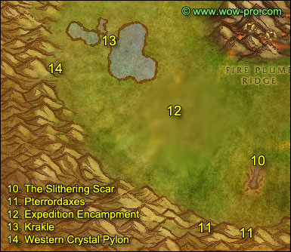
10. Go west to the Slithering Scar and clear yourself a path to the bug lair entrance at (50,76). Inside the bug lair at the first fork go left, clear the circular room and then stand in the middle of it, look in your inventory for a black vial named "Scraping Vial" and click it. If it doesn't work try different spots in this room until you get a Hive Wall Sample.
At this point you might already have gotten a Gorishi Scent Gland. If you didn't, keep on killing these bugs until one drops. It can drop from any of the bugs, inside or outside the lair, it doesn't matter.
11. Go directly south of the bug lair and up the mountain (50,88). You should find 2 Pterrordax there, kill them.
A bit further to the west you should find another of those spots up the mountains with 4 or 5 Pterrordax there (44,87), kill them. Stay at this spot until you get your 10 Pterrodax kills, you can kill some bugs while waiting on respawns.
12. Then get on your mount and ride to the Expedition Camp at (38,66), try to avoid the aggros as much as possible because most mobs are too tough for you here. At the Expedition Camp, look for a pile of crates named "Research Equipment" and loot them. Then go northwest, run away from any aggro if you have to, the lake is pretty safe so I suggest you just swim through it.
13. Go northwest until you reach the big rock on the other side of the lake. Behind this rock you 'll find a little goblin named Krakle, get his quest quickly [55] Find the Source. (Quickly because a Devilsaur roams at this place every now and then. )
14. Go directly west and a bit to the south and you will find the Western Crystal Pylon (23,57). Click it and examine it.
Ride northeast back to Marshall's Refuge and sell and repair.
If you haven't finished [52] Larion and Muigin, go out and kill some more flowers until you complete it. Go to the area which is southeast of the black pools where we killed the Tar beasts. There are plenty there and they are the easiest flowers to kill (65,27).
Then go back to Marshall's Refuge and turn in:
- [52] Alien Ecology
- [52] Larion and Muigin, Get the follow up [52] Marvon's Workshop
- [53] Expedition Salvation
- [53] The Eastern Pylon
- [53] The Northern Pylon
- [53] The Western Pylon, get the follow up quest [53] Making Sense of it from J.D. Collie. Turn it in.
You can bank the book you get as reward from this quest (it tells you how to combine crystals at the various pylons for some consumable crystals with effects like heal or damage shield, but nothing too great, so just bank the book to have more bagspace or destroy it).
You should be level 53 by now.
Level 53

Fly to Gadgetzan.
In Gadgetzan, turn in [54] Super Sticky and [53] Bungle in the Jungle, don't get the follow up quest.
Fly to Thunderbluff, go to the Elder Rise and turn in [50]Un'goro Soil at Ghede, a tauren standing behind the big tent. Go to Arch Druid Hamuul Runetotem, he should have a new quest for you: [50]Morrowgrain Research
Go to Bashana Runetotem, she's in the high tent next to the bridge. Turn in the quest and get the follow up [50]Morrowgrain Research.
**Search your inventory for something named "Evergreen Pouch". From now on, click it everytime the timer is ready, it will create an "Evergreen Herb Casing", open it and loot what's inside. It can be various herbs but sometimes it will be Morrowgrain, and that's what you need. You need 2 Ungoro Soil everytime you want to use the pouch, but you should still have about 20 left even after turning the quests.**
You will need a total of 10 Morrowgrain. Once you got 10 Morrowgrain you can stop using the Evergreen Pouch. I personally sold the seeds and the un'goro soil I had left after obtaining my 10 Morrowgrain, and also destroyed the Evergreen Pouch, because I like having bag space . Don't stand still and do nothing while waiting on the pouch timer though, go on with the next part of the guide! You can click on the Evergreen Pouch every now and then everytime the cooldown is refreshed, until you get 10 Morrowgrain.[/i]**
Hearthstone to Orgrimmar.
Go to "The Drag" and turn in the quest [52]Bone-bladed Weapons.
Sell, repair, restock consumables (5 stacks food/drink).
Put the following quest items in your bank if you lack space:
Krakle's Thermometer
Dinosaur Bones
Webbed Diemetradon Scales
Webbed Pterrordax Scales
I'll warn you when we need to pick them up from the bank.
Fly to Splintertree Post and then follow the road northeast until Azshara.
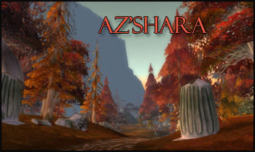
Right after entering Azshara you'll find Talrendis Point to the right (11,77). Stay away from the alliance npcs as much as possible and get the two quests from the tauren named Loh'atu:
[47] A Land Filled with Hatred
[47] Spiritual Unrest
The quests will be marked as low level and you won’t see an exclamation mark, take them anyway.
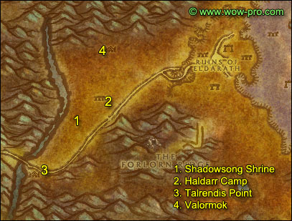
1. Go north on the other side of the road to Shadowsong Shrine (13,74). Kill 6 Highborne Apparitions and 6 Highborne Lichling. There's more of them just a bit further to the northeast
2. When done with that, go further to the northeast until Haldarr Encampment, kill Satyrs there until you have [47] A Land Filled with Hatred complete.
3. Go back to Talrendis Point and turn in the two quests.
4. Ride north/northeast to the Valormok, the horde outpost. Turn in [53]Betrayed and get the follow up [53]Betrayed.
Also get the quest [52]Stealing Knowledge.
Get the new flight path.
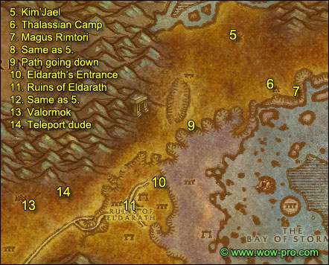
5. Ride northeast, go around the Ruins of Eldarath by the west side of it and keep going northeast. Avoid the Timbermaw Furlbogs, don't kill any of them even if they attack you, just run away. Avoid the other timbermaw camp "Ursolan", go around it by the east side and keep riding northeast until you get to sharp hill at (53,21), get to the top of it, you can only access it from the north. Uptop you'll find a goblin named Kim'jael. Get his quest [53] Kim'jael Indeed.
6. Just southeast of Kim'jael you'll find Thalassian Base Camp (55,26).
In the Blood Elf camp you'll find several crates named "Kim'Jael's Equipment" scattered around. Open them all, most of the time you'll find food in it, but 25% of the time you'll find Kim'Jael's compass, scope, etc. Just keep opening crates until you have all of Kim'Jael's items. Also watch out for a rare named "Magister Hawkhelm".
7. Once you have got all the Kim'Jael parts and completed the kill list of [53]Betrayed, go to the stone structure behind the elf camp, close to the sea (59,31). Click the altar there, turn in the quest and get the follow up [56]Betrayed. 3 Floating Crystals should spawn, right click one of them to destroy it, an elven defender should spawn. Move away from the stone structure and kill it. At some point Magus Rimtori should spawn inside the stone structure while you kill the defender, but since you moved away she won't aggro you. Kill the defender, drink back to full HP/MANA and kill her and loot her head.
8. Go back to Kim'Jael, turn in the quest, get the follow up [53] Kim'Jael's "Missing" Equipment.
9. Ride southwest and find the path going down to the Shattered Strand (45,37), it's right next to Ursolan, southeast of it. Go down this path.
10. You'll encounter some naga pretty soon, kill every naga on your way, go southwest, until you reach the Ruins of Eldarath by a path at (41,48).
11. Once inside the Ruins of Eldarath, look for the tablets listed in [52]Stealing Knowledge. They spawn at random locations, so all you have to do is search through the entire ruins while killing everything. The tablets look like this:
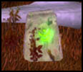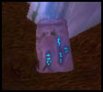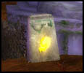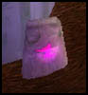
Don't forget to use the Evergreen Pouch every 10 minutes.
You should find "Some Rune" on one of the nagas, if you don't you're really unlucky, and you have to keep on killing stuff until it drops!
12. Find the slope taking you out of the Shattered Strand back on high ground at (46,39) and then ride northeast back to Kim'Jael, turn in the quest.
13. Ride southwest, back to Valormok Camp. Turn in [52]Stealing Knowledge, get the 4 follow up quests, which are Delivery quests. Turn in [56]Betrayed, get the follow up.
14. Ride east to find an elf with a blue question mark at (28,50). Turn in the quest Meeting with the Master and you'll be teleported to another place. Mount up and follow the path up the mountain and then go to the top of the tower, find Archmage Xylem and turn in the quest.
[52]Delivery to Archmage Xylem, get the follow up [52]Xylem's Payment to Jediga.
Hearthstone to Orgrimmar.
Sell, repair, restock consumables (4 stacks).
Go to "The Drag", find Jes'rimon, that troll npc we already dealt with for an Un'goro quest. He's on top of the alchemy building. Turn in [52]Delivery to Jes'rimon and get the follow up [52]Jes'rimon's Payment to Jediga.
Go to Belgrom Rockmaul in the Valley of Honor, in front of the warrior's building. Turn in [56]Betrayed.
This should make you ding level 54 or you should be close.
Level 54

Get out of Orgimmar, take a zeppelin to The Undercity. Go to the Apothecarium, find Andron Gant and turn in the delivery quest, get the follow up [52]Andron's Payment to Jediga.
Also in the Apothecarium get the following quests:
- [52]Seeping Corruption
- [52]A Sample of Slime...
- [56]...and a Batch of Ooze.
Ride out of the Undercity, take a zeppelin to Orgrimmar, fly to Thunderbluff. Go to the Elder Rise, find Magatha Grimtotem, turn in the quest and get the follow up [52]Magatha's Payment to Jediga.
In the tent next to Magatha turn in [50]Morrowgrain. You can destroy your Evergreen Pouch if you wish. If you didn’t manage to get enough Morrowgrain to turn the quest in, just abandon it and destroy the items related to it.
Fly to Valormok, Azshara. Turn in the 4 delivery quests.
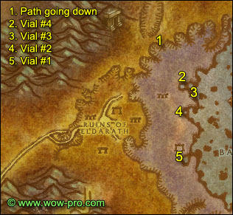
1. Ride northeast, to the same slope you used last time to go down (45,37).
2. This time keep going east until you reach the shore.
At (47,46) you should find a pool, close to the sea. Step inside the pool and right-click the "Empty Vial Labeled #4" from your inventory.
3. Just southeast of this pool, behind a white tower, you'll find another small pool (49,48), fill up the Vial #3 there.
4. A little further south you should find another pool, very close to the sea (48,51), fill up the Vial #2 there.
5. Further south you'll find the last pool, next to small mountain (48,60). Fill up the Vial #1 there.
If your hearthstone isn’t up, grind a little on the nagas until it is. If it’s more than 10 mintues away from being up, ride back to Valormok and fly to Orgrimmar.
Hearthstone to Orgrimmar. Put the four vials in your bank, we'll turn in that quest later on.
Sell, repair and restock consumables (5 stacks)
Fly to Splintertree Post, Ashenvale. Follow the road to Felwood.
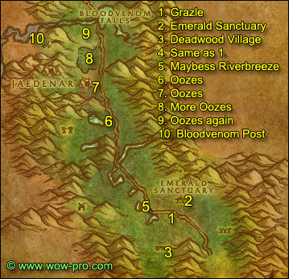
1. In Felwood follow the road until you find the Emerald Sanctuary, left of the road you'll see a furlbog named Grazle (50,84), get the quest [48] Timbermaw Ally from him. It’s marked as low level, don’t worry, take it anyway.
2. Go to the Emerald Sanctuary and get [51] Forces of Jaedenar from Greta Mosshoofand and [54] Verifying the Corruption from Taronn Redfeather. Also get the flight path.
3. Go southwest and you'll find Deadwood Village (49,88), start slaughtering Furlbogs. Keep doing that until you complete [48] Timbermaw Ally.
4. Go back to Grazle and turn in the quest, get the follow up [55] Speak to Nafien.
5. Get back on the road and ride west, at some point the road will turn north, look for a tauren npc named Maybess Riverbreeze next to a small green pool (47,83) (there will be a exclamation mark on the minimap) , get the quest [55]Cleansing Felwood from her.
6. Ride north following the road until (43,67), to the west should be a green pool, go there and kill Cursed Oozes. Kill all the oozes around that pool -there should be about 10- loot the Felwood Slime Sample off them, then get back on the road.
7. Ride north and after a while you should find another of those pools with oozes, next to Jaedenar (41,59). Kill all the oozes there, about 5 of them.
8. Just north of this pool, on the other side of the path to Jaedenar, you should find another of those pools, kill all the oozes there (40,56).
9. Ride north until you reach Bloodvenom River, you should find a lot of oozes on both sides of the river, kill them all while going west.
**You should normally have about 30 Felwood Slime Sample at this point, which is plenty to complete the quest [52]A Sample of Slime... even if you are unlucky. If you don't have 30 samples, just kill any ooze you find on your way in Felwood.**
10. Keep going west along the river and then go south to Bloodvenom Post.
Get the quests:
- [54]Well of Corruption
- [56]Wild Guardians
- [51]A Husband's Last Battle
Get the new flight path, sell junk and repair.
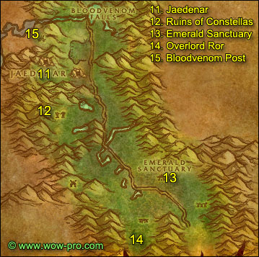
11. Get back on the road and go south to Jaedenar (40,57), clear yourself a path westwards through Jadefire Hounds, Guardians, Adepts and Cultists until you are done with [51] Forces of Jaedenar.
12. Get back on the road, ride south and then go west to the Ruins of Constellas (38,69), clear the way west till you find a corrupted moonwell at (32,67). Step inside the moonwell and right-click the Hardened Flasket in your inventory.
13. Get back on the road, ride south to the Emerald Sanctuary (51,82). Turn in [51]The Forces of Jaedenar, get the follow up [52]Collection of the Corrupt Water.
14. Ride southwest, back to Deadwood Village, clear the way through the furlbogs and find their chief, Overlord Ror, at the southernmost camp of the furlbog village (48,94). Kill him and loot Overlord Ror's Claw.
15. Ride back to Emerald Sanctuary, fly to Bloodvenom Post, turn in [54]Well of Corruption, get the follow up [54]Corrupted Sabers. Turn in [51]A Husband's Last Battle.
Sell and repair.
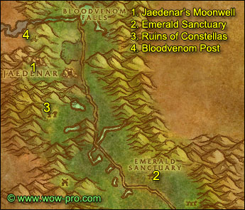
1. Ride to Jaedenar, clear the way west until you find a corrupted moonwell at (35,60), right click the Empty Canteen from your inventory.
2. Get back on the road and ride south to the Emerald Sanctuary, turn in [52]Collection of the Corrupt Water and get the follow up [52]Seeking Spiritual Aid.
3. Get back on the road and ride to the Ruins of Constellas, clear the way through the satyrs until the corrupted moonwell where we went earlier (32,67). Kill the satyrs around the well if there are any. Then step inside the well and right-click Winna 's Kitten Carrier from your inventory.
Clear the way out carefully, don't die or you'll lose your Corrupted Saber and will have to redo the quest.
4. Get back on the road and ride back to Bloodvenom Post while making sure the cat is always following you.
In Bloodvenom Post go to Winna Hazzard, then righ-click the Corruptee Saber and choose to release it. Turn in the quest [54]Corrupted Sabers.
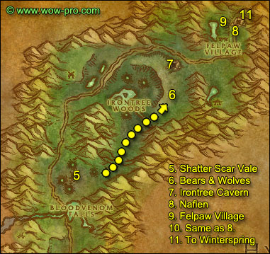
5. Get back on the road, ride north, shortly after the bridge go right into Shatter Scar Vale (39,44). Kill 2 Entropic Beasts, they are immune fire and deal fire damage. Walk around in the Shatter Scar Vale until you get the "Explore the craters" complete message. Further to the east and a bit to the north at the last crater you should find Entropic Horrors, they are just a bit higher level than the Entropic Beasts but still in your range. Kill two Entropic Horrors then get back on the road. If you don't find Entropic Horrors, kill Entropic Beasts until Entropic Horrors respawn instead.
6. On the northeastern part of the Shatter Scar Vale you should find a narrow path going north, mount up and go through this path then go northeast until you cross a small river. On the other side of the river you should find an area with Angerclaw Grizzlies and Felpaw Ravagers(54,28). Kill as many as possible, then go further north to the Irontree Cavern and kill Warpwood Elementals while waiting for Grizzlies and Wolves to respawn, then go back and kill the remaining ones you need to complete [52]The Strength of Corruption.
7. Go to Irontree Cavern as shown on map (55,15). Kill Warpwood Elementals until you get 15 Blood Amber, they always drop.
8. Get back on the road and follow it going east and then north until the entrance of Timbermaw Hold, talk to Nafien, turn in the quest. Get the other quest [55] Deadwood of the North.
9. Removed, skip to next point.
10. Removed, skip to next point.
**Optional: If you did Maraudon and have the quest [51]Seed Of life, inside timbermaw hold go under the bridge and to the north, keep going until you exit in Moonglade. In Moonglade go north straight to the shrine of Remulos (36,42), turn in [51] Seed of Life at Keeper Remulos. Go back to Timbermaw hold**
11. Go inside Timbermaw Hold through the first tunnel, after the bridge keep going east. Right outside the tunnel to the right you'll find Salfa, get her quest [58]Winterfall Activity.
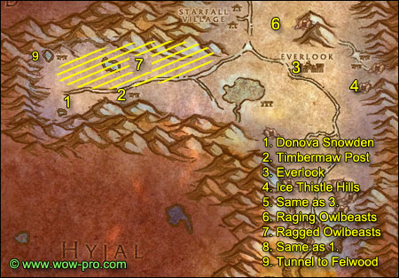
1. Ride south to Donova Snowden, turn in the quest [52] It's a Secret to Everybody, let her do her speech, and then get the follow up [52] The Videre Elixir, get the other quest [56]Threat of the Winterfall.
**From now on kill any Ragged Owlbeast you see on your way, until you have killed 15.**
2. Go east to Timbermaw Post (40,44). Kill the furlbogs there until you have completed [56]Threat of the Winterfall and found an Empty Firewater Flask. If this camp is too crowded, you can try the other one northwest of here at the Frostfire Hotsprings (31,37).
When you find the Empty Firewater Flask, right-click it to get the quest [56]Winterfall Firewater.
3. Ride east to Everlook (61,38), kill as many Ragged Owlbeast on your way as possible.
In Everlook get the quest [56]Are We There, Yeti?.
Sell, repair, and restock food/drink (4 stacks)
You can put the Felwood Slime Samples in the bank, we won't be needing them for a while.
Get the new flight path.
4. Go southeast of Everlook, to Ice Thistle Hills (65,42). Kill yetis there until you have 10 Thick Yeti Furs.
5. Go back to Everlook, turn in [56]Are We There, Yeti? Don't get the follow up.
You should be level 55 by now.
Level 55

6. Go northwest of Everlook, to the area shown on the map, you'll find a lot of Raging Owlbeasts there. Kill everything in the area, I advise you to just kill all the aggressive creatures close to you, including bears. If you try to sneak past mobs to just kill Owlbeasts you'll end up getting adds and things can get quite ugly in this area. Stay in this area until you have 15 Raging Owlbeasts kills.
7. Go to the area marked "7" on the map and hunt Ragged Owlbeasts until you have 15 kills.
8. Ride to Donova Snowden, turn in [56]Threat of the Winterfall and [56]Winterfall Firewater. Get the follow up [56]Falling to Corruption.
9. Ride northwest and go through the tunnel to Felwood.
In Felwood jump down to your right after you exit the tunnel.
Clear yourself a path to the camp which is on the upper level of Felpaw Village, northwest of the green pool. Clear the camp (which might be hard, so use everything you got if needed) and you should find a "Deadwood Cauldron" (60,5). Click it, turn in the quest and get the follow up [56] Mystery Goo. Also complete [55] Deadwood of the North. Turn it in right away at the furbolg next to the Timbermaw Hold entrance and get the follow up [55] Speak to Salfa. Go through the tunnel to Winterspring and turn the quest in at Salfa who is at the tunnel exit.
Go back to Donova Snowden, turn in [56] Mystery Goo and get the follow up [56] Toxic Horrors.
Hearthstone to Orgrimmar.
Sell, repair, restock consumables (5 stacks of food/drink).
Get the following quest items from your bank:
- Krakle's Thermometer
- Dinosaur Bones
- Webbed Diemetradon Scales
- Webbed Pterrordax Scales
- Mithril casing (or buy it now if you don't already have it)
Fly to Ratchet.
In Ratchet go to the small hut with the green roof, close to the sea (62,39). Turn in [52]Marvon's Workshop.
If you plan to go to Sunken Temple later on then get the follow up [52]Zapper Fuel.
In any case get the quest [55]Volcanic Activity. Just infront of the hut you should find Marvon's Chest, loot the Stone Circle from it.
From Ratchet ride south along the merchant coast and go east to the Tidus Stair (65,43), right next to the ocean you should find Islen Waterseer next to a hut.
Turn in [52] Seeking Spiritual Aid, watch her summon a water elemental spirit and then take her follow up [54] Cleansed Water Returns to Felwood.
Ride back to Ratchet, fly to Shadowprey Village, Desolace.
Follow the road to Feralas.
Shortly after entering Feralas, just west of the road you should see some ruins with a gnoll - Miblon Snarltooth - infront of it (45,11). Get off your mount, and watch this video, it shows you how to get the Evoroot without buying the bait from Gregan. Thanks Laurens from Twisted Nether (EU) for the video!
http://www.youtube.com/watch?v=_oI3iefJ3_w
Loot an Evoroot from one of the pedestals.
Go south to Gregan Brewspewer (45,25). Turn in the quest [52] The Videre Elixir.
Get back on the road and ride to Camp Mojache.
In Camp Mojache turn in [52]The Strength of Corruption, then fly to Gadgetzan.
Ride directly south to Marvon Rivetseeker at the Broken Pillar (52,45), turn in [51] The Stone Circle, get his 2 follow ups if you intend to go to Sunken Temple later on:
- [51] Into the Depths
- [52] Secret of the Circle
Ride west/southwest until the entrance to Un'Goro. (27,57)
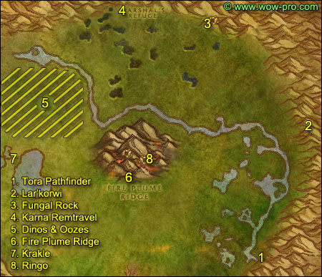
1. Down the slope in Un'Goro talk to Torwa Pathfinder (71,76). Get the 2 quests from him:
- [55] The Mighty U'Cha
- [56] The Bait for Lar'Korwi
2. Ride north until the eastern crystal pylon, go up the trail and further east and you should see some huge dinosaur skeletons at (80,49). Be full health/mana and ready to face a level 56 mob. Open Torwa's pouch in your inventory, loot the Preserved Threshadon Meat and the Pheromone Mixture, right click the meat, and then right click the Pheromone, Lar'korwi will appear, kill him. He's rather easy, I had no problems to solo it at all at level 55. Loot Lar'korwi's Head..
3. Ride north/northwest to Fungal Rock (63,16). Enter the cave, at the fork take the narrow path in the middle, then go right and keep going until you hit the end of the cave. Just be very careful where you fight the Un'Goro Gorilla, they call for help.
At the end of the cave in a room with a puddle of water and a rock in the middle you'll find U'cha, lvl 55 Gorilla. There's another gorilla in the same room but you can pull it solo if you wait for U'cha to go away. Then pull U'cha solo, kill it and loot his pelt.
Clear the way out of the cave, then kill all the apes outside the cave, make a clear path because you are gonna escort A-Me 01 out of this cave soon.
Once there's no ape left outside the cave, go back in and go right at the fork this time. After 2 or 3 more apes you'll find A-Me 01. Turn in the quest, get the follow up, turn it in (since you already have the mithril casing), then get the next follow up, [53] Chasing A-me 01. This will start the escort quest, once again the golden rule of escort quests, let A-me 01 infront, let her get hit first and then get the mobs off her.
4. Escort her until Karna Remtravel and turn in the quest. Just above of Karna Remtravel is Marshall's Refuge, go there and get the quest [55] Lost! from Spraggle Frock.
Sell and repair.
5. Go southwest until you hit the river (40,27). On the southern side of the river you'll find plenty of Dinos and some Oozes.
In this area, kill every Frenzied Pterrordax, Elder Diametradon and Ooze you find.
Keep doing this until you complete:
- [51] Shizzle's Flyer
- [51] Roll the Bones (they drop from the Elder Diametradons approximately 25% drop chance)
- [55] Beware of Pterrordax
And have gathered about 30 Un'goro Slime Samples. (This might take a while)
Warning: Be careful, 2 devilsaurs roam this area from time to time.
6. When you are done with these 4 quests, go southeast to Fire Plume Ridge, climb the mountain from the southern side in the middle (49,53). Find your way to the top of Fire plume ridge, you'll have to do almost a full circle around it for that, ignore the cave with Ringo for now. Kill every fire elemental on your way and you should get the 9 Un'Goro Ash you need.
When at the top of Fire Plume Ridge, next to the lava pool you should see a conic stone named "Fire Plume Ridge Hot Spot". Search your inventory for Krakle's Thermometer, right click it next to the conic stone, this should complete the quest [55] Finding the Source. Don't get too close to the cave at the top, there's a lvl 56 Elite elemental there, avoid it.
7. If you got 9 Un'Goro Ash already no need to kill more elementals, just get off fire plume ridge from the west side and ride west until Golakka hotsprings and find Krakle behind the geyser hill (30,50). Turn in the quest and get the follow up [55] The New Springs.
Ride east/southeast to Torwa Pathfinder (71,76). Turn in the 2 quests:
- [55] The Mighty U'cha
- [56] The Bait for Lar'korwi
8. Go northwest to Fire Plume Ridge (yes, again!). Climb on it from the southern side in the middle (49,53) then go a bit east to reach the cave where Ringo is (52,51). Turn in the quest [55] Lost! and get the follow up [55] A Little Help from My friends. Search your inventory for Spraggle's Canteen and put it on a hotkey. Everytime Ringo faints, click the canteen while being next to him. Get off the mountain by the eastern side, then go north, run to Marshall's Refuge while making sure Ringo always follows you, try to avoid mobs as much as possible. Run inside Marshall's Refuge until Spraggle Frock, you'll get the quest complete message.
Time to turn in some quests!
- [55] Beware of Pterrordax
- [55] A Little Help from my Friends
- [51] Roll the Bones
- [51] Shizzle's Flyer
Destroy Spraggle's Canteen.
You should be level 56 by now (largly).
Level 56

Hearthstone back to Orgrimmar.
Sell, repair, restock consumables (4 stacks); visit your class trainer.
You can put the Un'goro slime samples in the bank, for more bag space.
Fly to Winterspring.
Ride west and go to Donova Snowden, turn in [52]The Videre Elixir, get the follow up [52]Meet at the Grave. Don't turn in the other quests.
Ride back to Everlook and fly to Ratchet, turn in [55]Volcanic Activity.
Fly to Gadgetzan, go to the Gadgetzan grayveyard, just east of Gadgetzan (53,28). Drink the Videre Elixir, you'll die, but don't worry, no durability loss from this, it's normal. Release spirit but don't resurrect, go directly north from the Graveyard and up the mountain, you should soon see the yellow question mark on your minimap, go to it and talk to Gaeriyan, turn in and get the follow up [52] A Grave Situation. Go back to the graveyard, resurrect and click the gravestone named "A Conspicuous Gravestone" with the question mark, complete the quest and get the follow up [52] Linken's Sword. You can destroy the other Videre Elixirs.
Fly to Marshall's Refuge, Un'goro Crater. Turn in the quest [52] Linken's Sword, get the follow up [52] A Gnome's Assistance, go talk to J.D. Collie inside the crystal cave, turn in the quest, watch her do her speech and get the follow up [54] Linken's Memory.
Hearthstone to Orgrimmar if your stone is ready.
Fly to Emerald Sanctuary, Felwood.
Turn in [54] Cleansed Water Returns to Felwood, get the follow up [55] Dousing the flames of Protection.
Also turn in [54]Verifying the Corruption and [54] Linken's Memory, get the follow up [54] Silver heart.
Go west on the other side of the road and find Maybess Riverbreeze (47,83), turn in [55]Cleansing Felwood.
OPTIONAL: Talk to her and ask her for a Cenarion Beacon. From now on when you kill stuff in Felwood you can get Corrupted Soul Shards, which you will turn in later for Cenarion Plant Salves. With those salves you can cure corrupted plants in felwood and get consumables and buffs in return.
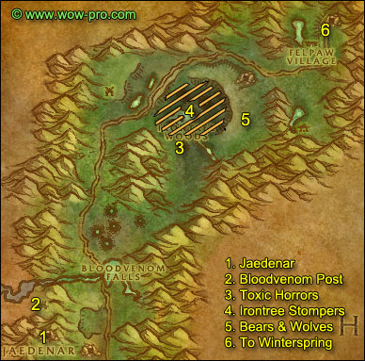
1. Get back on the road, ride to Jaedenar (40,57). in Jaedenar clear the way westwards until the corrupted moonwell you already went to before to fill up the vial. Enter the Shadow Hold (35,58).
At this point if you can find people to group it will be much easier. Dousing the Flames of Protection is doable solo (but kinda hard), on the other hand there's an escort quest which is very hard to solo, if not impossible depending on your class and equipment. It also depends on how crowded the area is, if there's lots of people killing stuff in the shadow hold already, it's doable solo. Anyway, give it a try solo, but grouping for this one is just easier.
Clear the way down the first tunnel, in the first room you'll find a captured elf named Arko'narin. This is the NPC that gives the escort quest, but to get it you first need to find a Blood Red Key from one of the mobs inside Shadow Hold, click it and get the quest [55] A Strange Red Key. You have to turn this quest at Captured Arko'narin later. The follow up will be the escort quest.
In the same room you can find the 1st and 2nd brazier (the 2nd one is on the slope going to the next tunnel), click them to turn them off.
If you are in a group, and get a Blood Red Key (the whole group can loot it if it drops), tell everyone to turn in the first quest at the captured elf. When everyone has turned in the first quest [55] A Strange Red Key, one person should start the follow up, which is the escort quest.
Note: You have to click on the elf through the cage. Some people try to click the cage itself, but that doesn't work.
Escort Arko'Narin to her equipment, then escort her out, things can get rough at times because she engages 2 or 3 lvl 55 mobs a the same time and is fragile until she has her equipment on. In the same room where her equipment is you'll find the 3rd and 4th Brazier, turn them off too. At the exit a 53 mob will attack you. This was an elite before, so now it is somewhat easier to do this quest, still it remains difficult for a single person.
Defeat it and then Arko'narin will leave and you'll get the quest complete message.
If you don't find anyone to group with and the escort quest is too difficult for you, just don't do it, clear your way inside the Shadow Hold and turn off the 4 braziers.
2. Clear the way out of Jaedenar, get back on the road and ride north then go west to Bloodvenom Post. Turn in [56]Wild Guardians and get the follow up [58]Wild Guardians.
3. Get back on the road and ride north until Irontree Woods.
Go to the crater at (49,27), you'll find plenty of Toxic Horrors there, kill them until you got 3 Toxic Horror Droplet. There's more Toxic Horrors all around the big green pool just north of the crater.
4. In the same area, kill Irontree Stompers until one of them drops an Irontree Heart.
5. Go up the plateau east of Irontree Woods, where you will find plenty of bears and wolves. Kill them until you have 11 Silver Claws.
6. Get back on the road and ride to Winterspring.
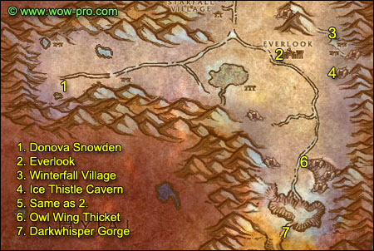
1. In Winterspring ride southeast to Donova Snowden, turn in [55]The New Springs and get the follow up [56]Strange Sources. Turn in [56]Toxic Horrors and get the follow up [57]Winterfall Runners.
2. Get back on the road and ride east to Everlook.
**Should you find the Winterfall Runners on your way, make sure to kill them and loot the Winterfall Crate. However don't actually go out of your way to look for them, just kill them if you encounter them while following the next paragraphs**
In Everlook get the quest [58]Are We There, Yeti?. Sell, repair and restock food/drink (4 stacks)
3. Go east of Everlook to Winterfall Village (66,33), kill 8 Winterfall Shamans and 8 Winterfall Ursa there.
4. Go south of Winterfall Village, to Ice Thistle Hills, this time enter the cave further to the east up the hills (68,42) and kill Ice Thistle Matriachs/Patriachs until you get 2 Pristine Yeti Horn. Also make sure that you are level 57 by the time you get out of the cave.
Level 57

5. Go back to Everlook, turn in [58] Are We There, Yeti? and get the follow up. Find a goblin named Legacki, she stands to the left of the Inn. Target her and right click Umi's Mechanical Yeti from your inventory.
Sell junk and repair.
6. Get out of Everlook, follow the road southeast / south until you find Owl Wing Ticket (63,59), the entrance of it is marked by two broken pillars and an elf named Ranshalla standing infront of it. Go inside Owl Wing Ticket and kill 13 Moontouched Owlbeasts. (If no Moontouched Owlbeasts are around keep killing the other owlbeasts, they are placeholders for each other)
7. Get back on the road and ride south, go over the ice bridge and keep going south until you discover Darkwhisper Gorge and get the complete message for [56] Strange Sources.
Hearthstone to Orgrimmar.
Sell, repair and restock consumables (4 stacks).
Fly to Emerald Sanctuary, Felwood. Turn in:
- [55]Dousing the Flames of Protection, get the follow up. [58]A Final Blow
- [55]Rescue From Jaedenar (if you managed to do it), get the follow up. [57]Retribution of the Light.
- Turn in [54] Silver Heart, get the follow up [54]Aquementas.
Ride north and go to Jaedenar, clear the way and enter the Shadow Hold. Clear inside the hold further than where you went last time past the last two braziers, past the red pool with the Oozes. Just a bit further down a slope you should find a room with an altar in it's middle, 4 warlocks/darkweavers around it, performing a ritual, and Rakaiah infront.
You can pull Rakaiah solo, the 4 warlocks will be aggro on you but won't attack as long as you don't directly attack them. After you got rid of Rakaiah, you will still be locked in combat mode because of the 4 warlocks, to lose combat mode you just have to run back some distance away from them until they forget you. Basically they never attack you unless you directly attack them. However the warlock's imp pets will attack you and you should dispose of them.
Kill the 2 other mobs on each side of the room and the one in the back, then you can kill each of the 4 warlocks one by one. When the room is clear, click on the Remains of Trey Lightforge on the altar, choose your reward and complete the quest [57] Retribution of the Light, get the follow up [57] The Remains of Trey Lightshadow.
Go past the Altar Room and down a spiral, after a couple of pulls you'll be facing a small bridge going up straight ahead and a slope going down to your left.
Go left and keep going in that direction until you reach a big room where you'll find Shadow Lord Fel'dan and his two succubus guards.
It wasn't an easy fight to solo, I basically used everything I had with the mage and rogue. I sheeped Shadow Lord Fel'dan and killed the two succubus fast. Same with rogue, I sapped the shadow lord and killed it last. With the warrior I used retaliation. Don't forget to loot the head of the Shadow Lord.
This part of the dungeon is just much easier with a group, you can try it solo but I recommend at least finding a person to duo it with.
Clear your way out of the Shadow Hold and out of Jaedenar, get back on the road and ride south to the Emerald Sanctuary, turn in the quests [57]The Remains of Trey Lightforge and [58]A Final Blow.
Fly to Bloodvenom Post. Turn in [58]Wild Guardians and get the follow up [59]Wild Guardians.
Fly to Everlook.
Sell, repair and restock food/drink (4 stacks).
Get on your mount and ride southeast/south along the road until Owl Wing Ticket. Kill Owlbeasts until you have 10 Berserk Owlbeast kills and have found a Blue-feathered Necklace off one of the owlbeasts. When you get the Blue-feathered necklace right-click it to get the quest [59]Guarding Secrets.
Ride back towards Everlook. Now we're gonna hunt for the Winterfall Runners, check the map below to see their route. I advise you start from Winterfall Village and follow the route westwards, to the Timbermaw Hold tunnel, until you find the Winterfall Runners.
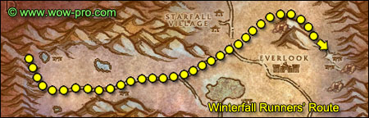
When you find the 3 Winterfall Runners (lvl 57), you don't have to kill all 3. Just kill one fast and run away, come back and loot the crate. They all drop it.
Ride to the Timbermaw Hold tunnel entrance (27,34) and turn in the quest [58]Winterfall Activity.
Ride south/southeast to Donova Snowden and turn in [56]Strange Sources and [57]Winterfall Runners. 3 Winterfall Ambushers will spawn, just run away, they aren't worth killing, give no loot and only 70xp each. Don't get the follow up (unless you want to do the optional circuit).
== OPTIONAL CIRCUIT ==
Only do this if you don't mind running around a bit, if you care for a nice exp reward and if you'd like one of these two items:
http://www.wowhead.com/?item=34423
http://www.wowhead.com/?item=34424
Be careful though, this might result in a huge timewaste as High Chief Winterfall tends to be heavily camped (depending on the server you play on and the time you are online at).
Get the follow up of [57]Winterfall Runners.
Ride all the way east to the Winterfall Village at approximately (67,37).
High Chief Winterfall is now a non-elite and he can be found in the cave above the Winterfall Village, along with two guards. Save your long CD abilities and use crowd control if you have. In the worst case solo down the chief fast, loot him and run away (watch out for Winterfall Runners, they might gank up on you if they happen to pass by).
While looting High Chief Winterfall you should find an item called Crudely-written Log. Loot and right click it, then ride back to Donova Snowden. Turn in both quests and get the follow up [59] Words of the High Chief. This quest is turned in in Emerald Sanctuary. We'll go to Bloodvenom Post soon, so simply remember to fly to Emerald Sanctuary later on to turn it in.
== END OF OPTIONAL CIRCUIT ==
Ride back to Everlook.
In the inn get the following 3 quests:
- [55]Sister Pamela
- [52]Duke Nicholas Zverenhoff
- [52]The Everlook Report
Fly to Bloodvenom Post, Felwood.
In Bloodvenom Post turn in [59]Wild Guardians and [59]Guarding Secrets, get the follow up [59]Guarding Secrets.
Fly to Thunder Bluff, go see Nara Wildmane on the Elder Rise and turn in [59]Guarding Secrets.
You should be level 58 by now or close.
Level 58

(If you lack experience, there is an optional circuit coming up soon, so don’t grind)
Fly to Gadgetzan.
In Gadgetzan, find a goblin named Sprinkle (she's close to the horde exit). Scare her away with the mechanical yeti.
Ride to Lost Rigger Cove (68,41), inside lost rigger cove go south to the other side of the pirate camp and then west until you find a stone circle (70,49).
Open the blue bag named "Eridan's Supplies", loot everything from it. Then step inside the circle and click the Book of Aquor. Aquementas, a lvl 54 elemental, will come to the circle and attack you. You don't have to kill it, just have to stand in the stone circle and let him attack you once. If you want to kill it, just know that he is immune to frost and deals frost damage (mages use Frost Ward). He should be a cakewalk at level 58.
You should now have the Silver Totem of Aquementas. If you do, you can destroy the "Book of Aquor", the "Silver Claws" and the "Irontree Heart".
Ride back to Gadgetzan. Fly to Marshall's Refuge in Un'goro Crater.
**For those who did Sunken Temple, at Marshall's refuge turn in [52] Zapper Fuel, don't get the follow up.**
Go inside the crystal cave and talk to J.D. Collie, turn in [54] Aquementas and get the follow up [54] Linken's Adventure. Go to Linken and turn it in, don't get the follow up unless you got a few people to help you. You'd need at least a healer and a tank type. Blazerunner is a lvl 56 Elite fire elemental and he hits for 400.
Anyway here is how to defeat Blazerunner, the last boss of the long quest chain "Linken's Adventure". Go to the top of fire plume ridge, clear all the elementals around to make sure they don't add during the fight. Equip the Silver Totem of Aquementas and put it on a hotkey. Click it to dispel Blazerunner's aura right at the start and everytime it reappears. Blazerunner is somewhat invincible when his aura is on, he keeps knockbacking people and every damage he takes is divided by 10. So be sure to always keep that aura dispelled.
Another thing, fight him inside his cave with your back facing the walls, so if he knockbacks you when the aura appears again you won't end up being tossed off the mountain or into adds.
He's a tough fight, I did it with a level 57 Priest, a level 55 Paladin and me (lvl 57 rogue) and it wasn't easy. On the other hand I soloed it with my lvl 57 frost mage, thanks to kiting, it took time and several attempts though. So I recommend saving that quest for when you are level 60 and have time to spend on it, unless you got enough people to help you immediately. Anyway if you do manage to kill Blazerunner, you must also go loot the Ornate Chest in his cave. Then turn in the quest at Linken.
Before you leave Marshal's Refuge, find the goblin named Quixxil and scare him with the mechanical yeti.
Hearthstone to Orgrimmar.
Train, sell, repair, restock consumables (4 stacks)
Take a Zeppelin to the Undercity.
In the Undercity, go to the bank. Get the 30 Felwood Slime Samples, the 30 Un'Goro Slime Samples, the 4 Filled Vials and the Black Dragonflight Molt (If you did the Thorium Point optional circle).
You can also deposit Umi's Mechanical Yeti in the bank for more bag space.
Go to the Apothecarium, turn in [52]Seeping Corruption, get the follow up, turn it in at Thersa Windsong right next to Chemist Cuely, then turn in the quest at Chemist Cuely.
Now look for Chemist Fuely, there should be an alchemy lab next to him with two pots on it: a red and a green one.
Right-click the green one and complete the quest, you'll receive an Un'Goro Tested Sample, open it and loot it. Keep doing this until you have 5 Pure Un'Goro Samples. Then do the same thing with the red pot, until you have 5 Corrupted Felwood Samples. You can then destroy the remaining samples you have.
Turn in [52]A Sample of Slime... and [56]...and a Batch of Ooze, get the follow up [55]Melding of Influences.
While you are in the Apothecarium, go visit the banshee queen - you have to go through the middle building and then through a curved corridor - and get the quest [56]The Champion of the Banshee Queen.
Go back to the bank, deposit the Encased Corrupt Ooze.
Go to the Innkeeper and set your hearthstone to the Undercity.
== OPTIONAL CIRCUIT: ==
I left this circuit from the old guide as optional circuit to allow people who lack experience to catch up. Also if you want the faction/gold from these quests, feel free to do this circuit (although it is getting rather low level at this point). Another reason why you might want to do these quests is to get Black Rock Depth/Spire prequesting done.
Fly to Kargath.
In Kargath get the quests [54]The Rise of the Machines from Hierophat Theodora and [52]Dreadmaul Rock from Thal'trak Proudtusk
Ride to the Searing Gorge, go to Blackrock Mountain, the path leading you through Blackrock Mountain starts at (33,75) go through Blackrock Mountain and enter the Burning Steppes.
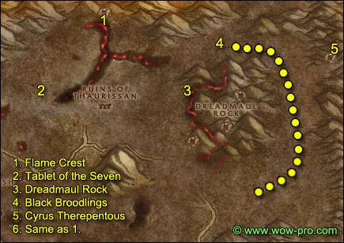
1. In the Burning Steppes get on the road and follow it going east for a while then go northeast to Flame Crest (65,24).
In Flame Crest get the new flight path and the following quests [52]Broodling Essence [50]Tablet of the Seven.
2. Go southwest to the Ruins of Thaurissan. Kill every War Reaver you see on your way. Keep going west until you reach the last rubbles of the Ruins of Thaurissan, with a dwarven statue inside (54,41). Infront of that statue you should find the Tablet of the Seven, right-click it and choose to "Transcript the Tablet".
Stay in the ruins and kill golems until you have 10 Fractured Elemental Shards.
3. Go east to Dreadmaul Rock, on the western flank of the mountain you should find a path going up (75,38). Clear the way to the top of the mountain, where you should find an altar with a ghost next to it: Sha'ni Proudtusk (80,45). Turn in the quest and get the quest [53]Krom'Grul.
Now we must find Krim'Grul. He can spawn at various locations in any of the caves composing Dreadmaul Rock, explore them all fully until you find Krom'Grul, kill him and loot Sha'ni's Nose-ring from him.
4. Go to the area which is north of Dreadmaul Rock (78,28), you should find Black Broodlings there. Search your inventory for Draco-Incarcinatrix 900 and put it on a hotkey. Use it on every Black Broodling before killing them. When they die while having the incarcinatrix aura on, a crystal will appear at their corpse named "Broodling Essence". You need 8 of these.
Make a semi circle around the eastern side of Dreadmaul Rock, that's where you'll find the Broodlings you need.
5. Before you leave this area go to the northeastern edge of it, you'll find a cave with Cyrus Therepentous in it.
Take his quest [54] A Taste of Flame, talk to him and click on the dialogue line, then turn in the quest, get the follow up [58] A Taste of Flame (Dungeon) if you intend to do Blackrock Depths later on.
6. Go back to Flame Crest, turn in [52]Broodling Essence, get the follow up [54]Felnok Steelspring. Turn in [50]Tablet of the Seven.
Fly to Kargath, turn in [53]Krom'Grul and [54]The Rise of the Machines, get the follow up.
Mount up and ride east to Lotwil Veratius (25,45), turn in [54]The Rise of the Machines. Only get the follow up if you intend to go to Blackrock Dephts later on.
Hearthstone to the Undercity.
Go to the bank and deposit Tinkee's Letter.
Sell, repair and restock consumables (4 stacks)
== END OF OPTIONAL CIRCUIT ==
Ride out of the Undercity, follow the road east until you find the Bulwark (83,68).
Turn in [52]The Everlook Report, at the same npc pick the other quest and turn it in instantly to get your Argent Dawn Commission. When you kill undeads while having this trinket equiped, you can collect Scourgestones from their bodies. I suggest equiping it from now on everytime you kill undeads in eastern and western plaguelands.
Turning in these Scourgestones at Argent Officer Pureheart gets you faction increases with the Argent Dawn and a token. These tokens are the only way to raise your faction with the Argent Dawn at a certain point in reverred, so save them until then. Check blizzard's official homepage to see what rewards you get at the different faction levels.
Get [53]Scarlet Diversions from High Executor Derrington. Right-click the Box of Incendiaries next to him and loot the Flame in a Bottle.
Get [58]The So-Called Mark of the Lightbringer from Mehlar Dawnblade. Don't get the other quests.
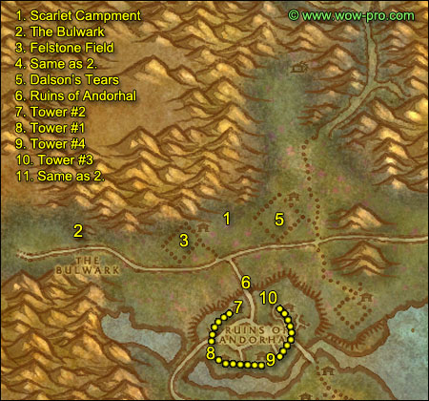
1. Ride east along the road and then north to the Scarlet Campment - northeast of Felstone Field - at (41,54). Clear the camp and then right-click on the Command Tent and once it is destroyed right-click the Scourge Banner from your inventory.
2. Ride back to the Bulwark, turn in the quest [53]Scarlet Diversions, get the two follow up [53] The Scourge Cauldrons and [56] All Along the Watchtowers.
Turn it in at Shadow Priestess Vandis and get the follow up [53]Target: Felstone Field.
3. Go east to Felstone Field (37,58). Clear yourself a path to the Cauldron in the middle of the field, when you get close, Cauldron Lord Bilemaw will spawn, kill it and loot the Felstone Field Cauldron Key from him, then go to the cauldron and click it, turn in the quest and get the follow up [53]Return to the Bulwark.
In the Felstone Field, go to the houses on the north side of the field, enter the one which is the most to the west (37,54).
On the 2nd floor of the house you'll find Janice Felstone, get the quest [52]Better Late than Never. (It’s marked as low level so no exclamation mark)
Go to the next house which (38,55) and find Janice's Parcel inside it. Click it, turn in the quest, then click it again and get the follow up [52]Better Late Than Never. (As the quest is marked as low level, you’ll have to click the box twice.)
4. Ride back to the Bulwark, turn in [53]Return to the Bulwark and get the follow up [55]Target: Dalson's Tears.
5. Ride east to Dalson'Tears (45,52), it's the field directly east of Felstone Field. Clear yourself a path to the Scourge Cauldron, when you get close Cauldron Lord Malvinious will spawn, kill it and loot his key, go to the Cauldron and click it, turn in the quest and get the follow up [55] Return to the Bulwark.
Go to the houses on the north side of Dalson's Tears, enter the right one (47,51). Clear what's inside and look on the floor for Mrs. Dalson's Diary, get the quest and complete it.
Get out of the barn and look around for a Wandering Skeleton, there is only one of this kind and he roams around the barn, so keep killing stuff around the barn until you find it, kill it and loot "Dalson Outhouse Key". Go behind the barn, you'll find an Outhouse (48,49). Open it, kill Farmer Dalson, loot Dalson Cabinet Key.
Go to the other house now (47,50), on the 2nd floor of it you'll find a "Locked Cabinet", click it and turn in the quest.
6. Get out of Dalson's Tears and go southwest to the Ruins of Andorhal. In Andorhal try to avoid the roads as much as possible, as level 56 elite abominations roam them. So just clear yourself a path through the destroyed houses. Also avoid the center of the town of course, there's a huge bunch of mobs there and Araj the Summoner (lvl 61 elite).
7. Clear yourself a path to the first tower you see on your right-hand side (42,66). Look for the "beacon torch" in your inventory and click it while standing next to the tower's door. You should get the message "Tower Two Marked".
8. Go southwest to the next tower (40,71). Place the beacon and you should get the message "Tower One Marked"
9. Go southeast and then east - avoid the center of the town - till you find the next tower (47,71). Place the beacon torch and you should get the message "Tower Four Marked".
10. Go north and then northwest to the last tower (45,64), place the beacon torch and you should get the quest message "Tower Three Marked".
11. Get out of Andorhal and ride back to the Bulwark.
- Turn in [56]All Along the Watchtowers, get the follow up [55]Scholomance.
- Turn in [55]Scholomance at Apothecary Dithers and get the follow up [57]Skeletal Fragments.
- Turn in [55]Return to the Bulwark and get the follow up [55]Target: Writhing Haunt.
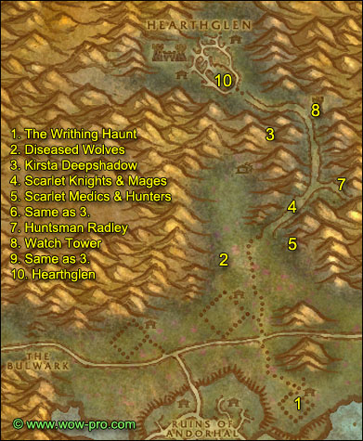
1. Ride east and then south to the Writhing Haunt (52,66). Clear a path to the Scourge Cauldron, when you get close to it, Cauldron Lord Razarch will spawn, kill it and loot the key. Clear what's around the Cauldron and go click it, turn in the quest and get the follow up [55]Return to the Bulwark.
Directly north of the cauldron in a small house you should find a tauren lying down on the floor, Mulgris Deepriver. Get his quest [54]The Wildlife Suffers Too.
**From now on kill any diseased wolf you find on your way until you have completed [54]The Wildlife Suffers too**
2. Go north/northwest to an area just north of Dalson's Tears (45,40), where you will find plenty of wolves to complete the quest. Kill everything in this area until you have 8 Diseased Wolf Kills. If needed, you can go grind on the Scarlet Lumberjacks just north of this spot while waiting for the wolves to respawn.
3. Go north to the Northridge Lumbermill, when you are next to the lumbermill, go northeast of it, follow a trail going down to a destroyed wagon. You'll find Kirsta Deepshadow there (51,28), get the quest [56] Unfinished Business.
4. You can find the Scarlet Knights and Mages you need to kill for the quest just southeast of Kirsta, on the road to Hearthglen.
5. For the Hunters and Medics go to the camp further south(51,44).
6. When you completed the kill list, go back to Kirsta and turn in [56] Unfinished Business, get the follow up.
7. Go back on the road just east of Kirsta.
At (54,34) the road forks off to the left and right. Go right and up the slope you will find Huntsman Radley (57,35). She can be pulled solo if you do it at the right moment, just wait for the mage next to her to move far enough.
8. Get back on the main road and this time at the fork go north, keep going north until you hit the watch tower (53,24). Kill the 2 guards infront of it, clear the 1st floor of the tower carefully, then wait for Cavalier Durgen to show up. He goes to the top of the tower then walks back to the entrance. Wait for him to come down, you can't kill him when he's on top, he has 3 guards with him there.
After killing Durgen, clear the way to the top of the tower and prepare for a tough fight: there are 3 scarlet mages on top of the tower, you can actually pull just 1 or 2 if you take your time and body pull carefully. Anyway, make sure you got all your cooldowns ready for this fight. After you have cleared the top of the tower, you should find a Holy Coffer, right-click it and loot the Mark of the Lightbringer.
9. Go directly back to where Kirsta is by going southwest and jumping down in the crater where she is. Turn in the quest [57] Unfinished Business, get the follow up.
10. Mount up and ride to Hearthglen (46,18), trying to avoid most mobs on your way. When you are at the entrance, open your map and search the following location with your cursor: (45,18). Now clear your way to that location, where you should see a tower. Kill the two guards at the entrance and climb up the tower. Run around on the top floor until you get a quest complete message. Exit the tower, mount up and get back to Kirsta. Turn the quest in.
You should be level 59 by now or close.
Level 59

Hearthstone to the Undercity.
Right after warping to the Undercity you should see a yellow question mark on your minimap labelled as "Royal Overseer Bauhaus".
Go to him and turn in the quest [52]Better Late Than Never, get the follow up [52]The Jeremiah Blues. You can turn this quest just a few steps away, under the stairs leading to the bank. Get the follow up get the follow up [52]Good Luck Charm.
Sell and repair, restock consumables (5 stacks).
Ride out of the Undercity and back to the Bulwark.
- Turn in [55]Return to the Bulwark, get the follow up [58]Target: Gahron's Withering.
- Turn in [58]The So-Called Mark of the Lightbringer, get the follow up [58]Defiling Uther's Tomb.
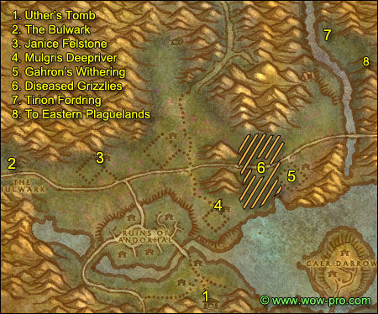
1. Ride to Uther's Tomb (52,81), look at the map below to see the path to take. Uther's Tomb is guarded by a level 58 elf npc, pvp flagged. If you attack it you'll be pvp flagged, if you don't want that you can just wait for him to do his patrol behind the statue. Equip the Corrupted Mark of the Lightbringer in your off-hand slot and wait for the 30 second cooldown, get close to the statue and right-click the Corrupted Mark of the Lightbringer directly from your off-hand slot.
2. Go back the way you came from to the Bulwark. Turn in [58]Defiling Uther's Tomb.
3. Go east to the Felstone Field, go into the left house (38,54) on the 2nd Floor. Turn in the quest [52] Good Luck Charm at Janice Felstone and get the follow up [54] Two Halves Become One.
Get out of the house and look for a Jabbering Ghoul wandering the area in front of the barn. If it's not there just keep the area clean until it respawns. Kill it and it will drop a "Good Luck Other-Half-Charm".
Once you have the other half charm, go back to Janice Felstone, right click on the other-half-charm in your inventory. Turn in the quest.
4. Get back on the road and ride east, then go southeast to the Writhing Haunt. Clear the way to the house with the tauren lying down on the floor, turn in [54]The Wildlife Suffers Too, get the follow up [56]The Wildlife Suffers Too.
**From now on kill any Diseased Grizzly you see until you have killed 8 (at 54,48 you’ll find a lot of them)**
5. Go northeast to Gahron's Withering (62,57). Clear a path to the Scourge Cauldron, when you get close Cauldron Lord Soulwrath will, appear, kill it. He's harder than the other cauldron lords, he knockbacks and silences, so be careful where you fight him. Loot his key then go to the Cauldron, turn in the quest and get the follow up [58] Return to the Bulwark.
6. Go to the area which is in between Garon's Withering and the Writhing Haunt. There should be plenty of bears there. Kill everything in this area until you have 8 Diseased Grizzly Kills, then go turn in [56]The Wildlife Suffers Too at the Writhing Haunt. Get the follow up [56]Glyphed Oaken Branch.
7. Ride east until you hit Thondroril River, go north along the river bank, then cross the river so you are on the eastern bank and ride north until you find a house. In front of it you'll see Tirion Fordring, get his 3 quests:
- [56] Demon Dogs
- [56] Blood Tinged Skies
- [56] Carrion Grubbage
**From now on, kill on sight the following:
Plaguehound Runt
Carrion Worm
Plaguebat**
8. Go south along the river and then east into Eastern Plaguelands.
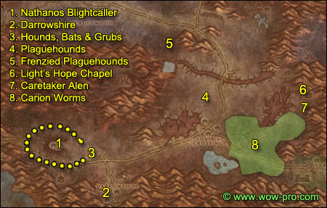
1. Go southeast while killing everything on the way. Find the Marry's Stead. You should find Nathanos Blightcaller there (27,75). Turn in [56]The Champion of the Banshee Queen. Get the follow ups:
- [58]To Kill With Purpose
- [58]Un-Life's Little Annoyances
- [60]The Ranger Lord's Behest
**Add the following two mobs to your kill-on-sight list:
Noxious Plaguebat
Monstrous Plaguebat**
2. Go southeast to Darrowshire, keep killing everything on sight that you need for quests, there should be plenty.
Inside Darrowshire, find a small destroyed house on the western side of Darrowshire. You should find Pamela Redpath there, turn in the quest [55] Sister Pamela and get the follow up [55] Pamela's Doll.
Now you must find the 3 parts of pamela's doll, they can be in any of the other houses in Darrowshire, mostly on the 2nd floor of it. Look on the floor for some brown objet. Everytime you get close to one of the doll parts, a level 55 ghost spawns and attack you.
Once you have Pamela's Doll's Left Side, Right Side and Head. Right click them in your inventory to combine them. Go to Pamela and turn in the quest. Get the two follow up quests:
- [56] Uncle Carlin
- [56] Auntie Marlene
3. Go back towards the Marry's Stead and keep doing wide circles around it killing everything until you got 30 Plaguebat and 20 Plaguehound Runts slain. This is the best area to find them.
4. Go east to the area north of the Infectis Scar and Corin's Crossing. Kill everything around until you have 5 Plaguehound Kills and 20 Noxious Plaguebat Kills. Also kill Carrion Grubs if you still miss Slabs of Carrion Worm Meat.
5. Once you're done with the above, go to the area which is north of Blackwood Lake (51,41). You should find Frenzied Plaguehounds and Monstrous Plaguebats around this area, kill 5 Frenzied Plaguehounds and 10 Monstrous Plaguebats. Also kill Carrion Devourers if you still need carrion meat.
6. Go southeast, around the Pestilent Scar by the north of it and then go southeast to Light's Hope Chapel (81,59).
Get the flight path. Turn in [52] Duke Nicholas Zverenhoff. Turn in [56] Uncle Carlin, get the follow up [55] Defenders of Darrowshire.
7. Just a bit south of Light's Hope Chapel find Caretaker Alen (79,63). Get the quest [55] Zaeldarr the Outcast from him.
Note: Evil bat eyes, can be used to get Darkmoon Faire Tickets, which you can use to obtain certain items. If you aren't interested in the Darkmoon rewards you can sell the eyes at the AH for nice cash.
8. Check how many "Slab of Carrion Worm Meat" you need, then go kill in the area south and southwest of Light's Hope Chapel until you got your 15 Slabs Carrion Worm Meat.
Hearthstone to the Undercity.
Sell, repair, restock consumables (5 stacks).
Deposit the Glyphed Oaken Branch in the bank.
Ride out of the Undercity and ride east to the Bulwark.
Turn in [58]Return to the Bulwark. Get the quest [55]A Plague Upon Thee from Mickey Levine. Go to High Executor Derrington and get/turn in the quest "Mission Accomplished!".
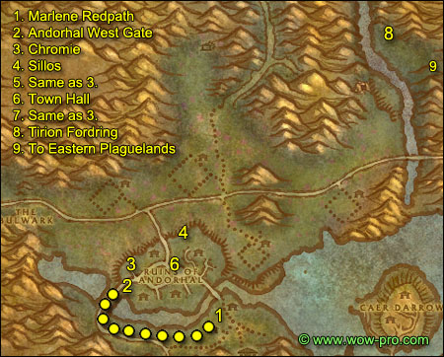
1. Go inside the Western Plaguelands and ride southeast around Andorhal, then east again to Sorrow Hill and find Marlene Redpath in the only house there is (49,78).
Turn in [56] Auntie Marlene and get the follow up [56] A Strange Historian.
Search the graveyard just north of the house where Marlene Redpath is, look for "Joseph Redpath's Monument" among the graves (49,76) (it’s the sparkling one ). Click the grave and get Joesph's Wedding Ring.
2. Go west for a while and then north to Andorhal, enter the Ruins of Andorhal by the western entrance.
3. Just a bit inside Andorhal go to the house to the north, it's the only house around with a floor and not totally destroyed (39,68). Inside the house go to the 2nd floor, in one of the rooms you'll find Chromie. Turn in [56] A Strange historian, get the follow up [56] The Annals of Darrowshire. Also get the other quest [56] A Matter of Time.
4. Go to the northern gate of Andorhal, and east of the first watch tower you'll find two wooden silos (45,62) which look like this:
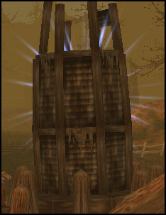
Get full hp/mana, get next to one of them and click your Temporal Displacer (looks like a horn). 1 to 3 lvl 56 worms will spawn and attack you. The worms only appear when the silo is sparkling blue. They take a while to sparkle again after you use the temporal displacer next to them. There's 3 more silos just a bit more to the east.
Keep doing that until you have 10 Temporal Parasites slain.
5. Go back to Chromie, turn in [56] A Matter of Time and get the follow up [56] Counting Out time.
Now what you have to do is to check every destroyed houses in Andorhal and look for Small Lockboxes like this:
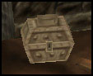
Loot the Andorhal Watch from it. Keep doing this until you have 5 Andorhal Watches.
6. Go to the town hall (with a tower clock) which is in the middle of Andorhal, close to where Araj the Summoner is, you can sneak in the town hall without having to fight any of the bunch of mobs close to it.
Inside the town hall you'll find several "Musty Tome" lying on the floor. When you click one, there is a chance you will find the Annals of Darrowshire, but there is a higher chance that you will get a "Ruined Tome" and 1 or 2 level 57 mobs will attack you. They give no loot and no exp. Hoewever there is a trick to know which tome is the right one. There is a slight graphical difference. The pages of the fake tomes have two-tone colored pages, lightbrown and white, like this one:
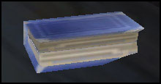
The good tome looks "newer", and it's pages only have one color tone, like this one:
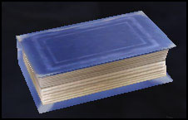
You can easily see the difference if you zoom in 1st person view and put your mouse pointer over the books to highlight them. Loot the Annals of Darrowshire.
7. Go back to Chromie, turn in [56] Counting Out Time. The Attuned Dampener you get as a reward is only useable on Araj the Summoner, so save it for later when you are 60 and do the big quests. Killing Araj is necessary to get your Scholomance key and another quest for a decent trinket. You'll need a solid group of 60s to kill him, but the Attuned Dampener will help.
Turn in [56] The Annals of Darrowshire, get the follow up [56] Brother Carlin.
Now you should also have finished [57] Skeletal Fragments, if you haven't, kill some more skeletons while you are in Andorhal.
8. Get out of Andorhal by the north gate, then go east till Thondroril River and ride north to Tirion Fordring (7,43).
Turn in [56] Demon Dogs, [56] Blood Tinged Skies and [56] Carion Grubbage. Get the follow up [56] Redemption. Listen to Tirion's tale, turn in the quest and get the follow up [57] Of Forgotten Memories.
This should make you ding 60 or you should be close. Congratulations!
Level 60

You can continue with Jame’s Outland guides right now, however there is another alternative:
Finishing this guide will take you halfway through level 60 or more. You are probably wondering why you should continue questing in the old world. The simple reason is that at level 70 you will want your flying mount and eventually you will also want your epic flying mount. Now all the quests in the Outlands, especially the high level ones give an awesome amount of gold at level 70 and questing has definitely become one of the best ways to make gold in the game without buying any. Doing Jame’s guides half a level ahead will make it easier to breeze through the Outland guides and will leave you with almost half a level (69-70) worth of quests to make gold. (Don’t forget, every quest you complete at level 70 will convert the experience you gain into gold)
Generally in my opinion you should not listen to people who suggest going to Outlands at level 58. I think it’s a grave mistake to waste 2-3 levels full of quests from the old world, most of which give more experience now and have been made easier with patch v2.3. Players who go to Outlands at level 58 do the quests in Hellfire Penninsula (which are much more difficult to do at level 58) and when they are done, they stand around at level 59 and don’t know what to do anymore, because all the other Outland quests are too high level for them. We had many posts on our site from people who complained about exactly that problem, so do not make the same mistake. Either start with Jame’s Outlands Guides at level 60 or if you want to make an extra amount of gold finish this guide first, then go to Outlands.
9. Ride to Eastern Plaguelands.
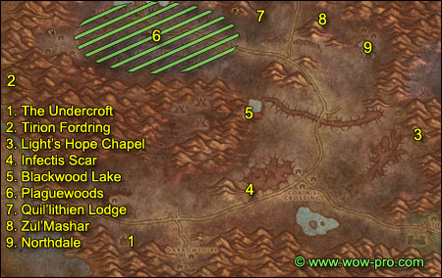
1. Go southeast to the Undercroft, which is directly south of the Marry's Stead.
Behind the crypt in the Undercroft you'll find Tiron Fordring's Grave (28,86). Next to should be a "Loose Dirt Mound". This is where some classes need help, this almost impossible to do solo unless you use a lot of creativy and everything you got. Anyway here is what happens when you click the dirt mount, Mercutio Filthgorger and 3 Dwarf Graverobbers spawn and go to the dirt mound, if you are close they of course jump you.
They all hit hard, especially Mercutio, and all have a lot of hit points for non elites. Here is what I suggest:
As soon as you click the dirt mount, run to the other side of the fence, you can jump over it if you walk up the mountain a bit. The 4 dwarves will walk to the grave and stand there.
You have two ways to do this now:
1) Polymorph Mercutio (if you have a mage with you) and kill the 3 gravediggers. Then bandage up and kill Mercutio, loot his hammer.
2) Ignore the 3 adds and go all out on Mercurio, loot the hammer and run.
Use creativity with the classes you have!
Ex: I could solo it with my rogue and my mage at level 58. With the rogue I simple used evasion and focused on Mercutio then I vanished as soon as he died. I didn't even need a potion.
With the mage I polymorphed Mercutio, frost nova'd the 3 guards and AoE'd them to death as quick as I could. They I re-polymorphed Mercutio, used evocation, bandaged up and then killed him.
However some classes and some talent specs probably can't manage it, so try to get some help if you can't solo it.
And if you don't get help immediatly, there's something to do in the Undercroft while wait for someone to come help you:
Go inside the crypt (27,85), clear the way down, kill Zaeldarr the Outcast and loot his head.
In the same room look for a "Torn Scroll" on the floor, click it can get the quest [60] Hameya's Plea.
If you still didn't get anyone to help you on [57] Of Forgotten Memories, grind on the trolls in the Undercroft while waiting for someone to help you. It just takes 10 min! Call a guildmate or something.
2. Go back to Tiron Fordring, turn in [57] Of Forgotten Memories, get the follow up [58] Of Lost Honor.
Hearthstone to Undercity.
Go train, sell junk, restock on food/arrows etc. Fly to Light’s hope Chapel.
3. Turn in [56] Brother Carlin, get the follow up [57] Villains of Darrowshire and [56] Heroes of Darrowshire.
Turn in [55] Zaeldarr the Outcast further to the south at Caretaker Alen.
4. Ride west to the Infectis Scar by passing Corin's Crossing by the south side.
Go down the Infectis Scar at (49,74), then go to
(53,65) where you'll find the "Shattered Sword of Marduk", as marked on the map. It looks like this:
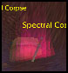
Loot it.
Get out of the Infectis Scar by the way you came in.
5. Go north to Blackwood Lake (49,51). Take a dive, in the middle of the pool at the bottom you'll see Ghosts of Darrowshire fighting each other, amongst them you should see a glowing violet skull named "Horgus Skull" (51,50), it looks like this:
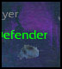
Loot it.
6. Go west to the Plaguewoods. In the Plaguewoods look around for Large Termite Mounds and loot them:
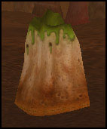
Kill stuff inside Plaguewood while looking for those termite mounds, but also try to find as many Cannibal Ghouls as possible. Anytime you kill one of these, a Spirit of Darrowshire will appear, right click it to free it. You need to free 15 Darrowshire Spirits. The Cannibal Ghouls are not so numerous though, so it will take a while, consider this as a mini grinding session, plus you are getting faction with the Argent Dawn and Scourgestones.
7. When you are done with both [55] A Plague Upon Thee and [57] Defenders of Darrowshire, go east to the Quel'Lithien Lodge (51,22). Clear yourself a path to the main building, and clear towards the right-hand wing. You should find two level 60 Quel'Lithien Protectors, kill them and then loot the Quel'lithien Registry, which should be lying on a bench.
Before you leave Quel'lithien Lodge, kill as many elves as needed to complete the quest [60]The Ranger Lord's Behest.
8. Go east to Zul'Mashar (64,24). Clear the way up the slope, and to the east, you'll soon face a big pyramid. At its base you should see tombs with some trolls roaming about them. One of them is Infiltrator Hameya.
Clear some of the trolls until you get a clear pull on Hameya, pull him solo and kill him, then loot his key.
9. Clear your way out of Zul'Mashar then go southeast to Northdale, take a dive in the pool which is just south of Northdale. Clear the elementals in the way. At (71,33), next to a cage you should see a white flag with a blue runed on it named "Symbol of Lost Honor":
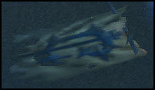
Loot it.
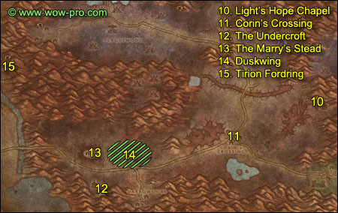
10. Ride southeast to Light's Hope Chapel.
Turn in [55] Defenders of Darrowshire and [57] Villains of Darrowshire. Get the quest [56] Heros of Darrowshire (if you haven't already).
11. Ride west/southwest to Corin's Crossing, kill every undead you find there until you have 7 Living Rot. You must be rather quick because the living rot only lasts 10 minutes. As soon as you have 7, right-click the Mortar and Pestle from your inventory, you should receive some Coagulated Rot.
12. Ride west and slightly south to the Undercroft. Right behind the crypt in the Undercroft you should find a "Mound of Dirt". Not the one next to Tiron's grave, the other one close to a charriot (28,86). Click it, turn in [60] Hameya's Plea.
13. Ride north to the Marry's Stead. Turn in the 3 quests, take the follow ups.
14. Go back and forth between Marry’s Stead and Crown Guard Tower until you spot a huge bat called Duskwing. Kill it and go back to Marry’s Stead to turn the quest in.
15. Ride northwest back to Tirion Fordring, turn in [58] Of Lost Honor and get the follow up [58] Of Love and Family.
Go south and then west back into the Western Plaguelands.
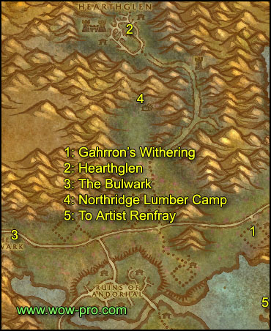
1. First make a stop at Gahrron’s Withering. There in front of the first building when you arrive from the north you’ll see a glowing shield looking like this:
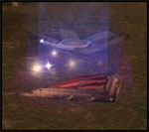
Clear the mobs around it then loot the shield.
2. Mount up and ride to Hearthglen. Clear your way into the village until you see the townhall:
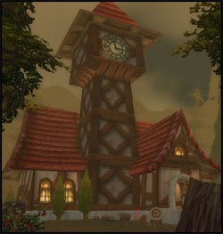
Clear your way inside and loot the glowing object from the table.
3. Follow the road south then west until the Bulwark.
In the Bulwark turn in [55]A Plague Upon Thee and get the follow up. Also turn in [57]Skeletal Fragments and get the follow up [57]Mold Rhymes With...
4. Go back to the Western Plaguelands and ride northeast to Northridge Lumber Camp.
Go straight to the lumber mill which is at the northeastern tip of the lumber camp.
Inside the lumber mill you should find a big crate named "Northridge Lumber Mill Crate". Click it and place the Termite Barrel on it. A barrel with green smoke should appear, click it and get the follow up.
5. Ride south, get back on the road, then go east for a while and then go south towards the isle of Caer Darrow. Swim southeast to Caer Darrow isle, on the western side of Caer Darrow, find Artist Renfray in a wooden house (65,75). Turn in [58] Of Love and Family and get the follow up [60] Of Love and Family if you plan on going to Stratholme.
Hearthstone to the Undercity.
Sell, repair, restock food and drink (4 stacks).
Fly to Light’s Hope Chapel. Turn in [56] Heroes of Darrowshire.
--------------
OPTIONAL (can take some time): Take the follow up and ride north to Browman Mill. Start clearing your way up and look for Scourge Champions. Everytime you kill one you’ll get to loot a skull. Use the mystic crystal from your inventory and if you are lucky you’ll get the quest item. You need five of those resonating skulls. If there are no Scourge Champions around anymore, kill everything around as every mob in that area and on top of the hill is a placeholder for the champions. The quest is turned back in at Light Hope’s Chapel.
OPTIONAL (can take some time, difficult for some classes): Once you are done ride northwest and search for Borelgore. He can be found pathing this area:
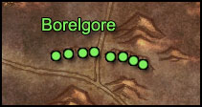
Clear everything around him then kill him. The quest is turned in at Marry’s Stead.
--------------
Get back to Light’s Hope Chapel and fly back to Undercity.
Get the following items from your bank:
- Umi's Mechanical Yeti
- Tinkee's Letter
- Encased Corrupt Ooze
- Glyphed Oaken Branch
Ride out of the Undercity and take the zeppelin to Orgrimmar.
Take 2x Thorium Bars with you.
Fly to Everlook, Winterspring.
In Everlook, turn in [58] Are We There, Yeti? at Umi Rumplesnicker.
Turn in [54] Felnok Steelspring, don't get the follow up.
Fly to Thunderbluff, in Thunder Bluff go to the Elder Rise and turn in [56]Glyphed Oaken Branch at Nara Wildmane.
Fly to Gadgetzan, turn in [57]Mold Rhymes With... at Krinkle Goodsteel, get the follow up [57]Fire Plume Forged.
Fly to Un'goro Crater, ride south to the top of fire plume mountain, (49,46). Right-click the Skeleton Key Mold from your inventory while standing very close to the lava, you should receive an Unfinished Skeleton Key.
Get off Fire Plume Ridge by the southern side and look for a Primal Ooze in the area south of the mountain (50,67). When you find one, engage it and before killing it right-click the Encased Corrupt Ooze from your inventory. You will release a little ooze which will merge with the Primal Ooze and create a Gargantuan Ooze. Kill it and loot the Merged Ooze Sample off it.
Get on your mount and ride northwest till you reach the mountain on your left-hand side, ride north along the mountain until you find two stone pillars (29,22). From there, follow the path going up the mountain until you zone into Silithus, keep going west on the road until you reach Cenarion Hold. In Cenarion Hold find the Wyvern Master and get the new flight path.
Get the following quests:
- [55] Securing the Supply Lines from Windcaller Proudhorn.
- [55] Deadly Desert Venom, from Beetix Fickelspragg on the 1st Floor of the Inn.
- [58] The Twilight Mystery from Geologist Larksbane
- [60] Secret Communication from Bor Wildmane
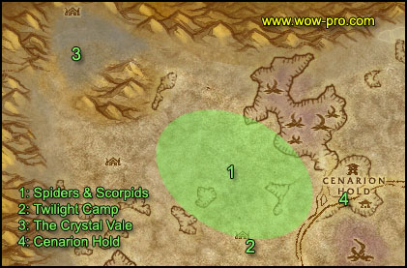
1. Get out of Cenarion Hold by the west side, keep going west a little bit, you'll quickly encounter Scorpids, Spiders and Worms. Kill all of them on sight. Move to the next paragraph if you run out of mobs to kill in the blue area shown as "1" on the map.
2. Go to the Twillight Base Camp (41,42). Kill the Twilight mobs. There is also a lot of scorpids, spiders and worms in the area north of the twilight camp. Keep kiling around this camp until you complete [60] Secret Communication, [55] Deadly Desert Venom and [55] Securing the Supply lines.
3. When done with all 3 above quests, go northwest until you are in the northwestern most corner of Silithus named "The Crystal Vale" (20,18). Look around for "Twilight Tablet Fragments", they look like this:
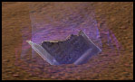
4. As soon as you have 8 tablets, go back to Cenarion Hold and turn in the 4 quests, you can get the follow ups if you wish, we won't be doing them in this guide.
Hearthstone to the Undercity, go to the Apothecarium and turn in [55]Melding Influences.
Get out of the Undercity and ride east to the Bulwark. Turn in [55]A Plague Upon Thee and [57]Fire Plume Forged. You can get the follow up if you wish, they are for the Scholomance Key and you'll need a group for the next step.
- Original Guide & Picture Editing: Jame
- Revamp, Text Formating & Picture Editing: Snowflake
© Copyrights www.wow-pro.com All Rights Reserved

